**CASE MANAGEMENT SYSTEM**

**PROJECT REPORT**

**For the partial fulfillment for the award of the degree**

**Of**

**POST-GRADUATION DIPLOMA**

**IN**

**INFORMATION AND COMMUNICATION TECHNOLOGY**

**(PGDICT)**

**Batch No-44**



**BKIICT, Bangladesh Computer Council**

Sher-e-Bangla Nagar, Dhaka-1207

**BKIICT, Bangladesh Computer Council**

Sher-e-Bangla Nagar, Dhaka-1207

**BKIICT, Bangladesh Computer Council**

Sher-e-Bangla Nagar, Dhaka-1207

**BKIICT, Bangladesh Computer Council**

Sher-e-Bangla Nagar, Dhaka-1207

**BKIICT, Bangladesh Computer Council**

Sher-e-Bangla Nagar, Dhaka-1207

**BKIICT, Bangladesh Computer Council**

Sher-e-Bangla Nagar, Dhaka-1207

**BKIICT, Bangladesh Computer Council**

Sher-e-Bangla Nagar, Dhaka-1207

**BKIICT, Bangladesh Computer Council**

Sher-e-Bangla Nagar, Dhaka-1207

**BKIICT, Bangladesh Computer Council**

Sher-e-Bangla Nagar, Dhaka-1207

**BKIICT, Bangladesh Computer Council**

Sher-e-Bangla Nagar, Dhaka-1207.

**09 September 2024**

**PROJECT REPORT**

**On**

**CASE MANAGEMENT SYSTEM**

Submitted To

**Madho Sudun Chanda**

Regional Director

and

Course Coordinator PGDICT, Batch-44

BKIICT, Bangladesh Computer Council (BCC)

Under the Supervision of

**Muhammad Shajjad Hossain Khan**

Managing Director, Zend IT Solution Ltd.

and

Instructor PGDICT, Batch-44

BKIICT, Bangladesh Computer Council (BCC)

E-mail: [shajjadhossain81@gmail.com](mailto:shajjadhossain81@gmail.com)

Submitted by

|  |  |  |  |  |  |  |  |  |  |  |  |  |
| --- | --- | --- | --- | --- | --- | --- | --- | --- | --- | --- | --- | --- |
| |  |  | | --- | --- | | **Name** | **Roll** | | **Anika Akter** | **05** | | **Nilufar Easmin** | **08** | | **Nadia Islam** | **09** | | **Mst. Peya Khatun** | **12** | |  |  | |
|  |
|  |
|  |

**Course: Post Graduation Diploma in ICT (PGDICT), Batch-44**

**BKIICT, Bangladesh Computer Council**

E-14/X, ICT Tower, Agargaon,

Sher-e-Bangla Nagar, Dhaka-1207.

**BKIICT, Bangladesh Computer Council**

Sher-e-Bangla Nagar, Dhaka-1207

**BKIICT, Bangladesh Computer Council**

Sher-e-Bangla Nagar, Dhaka-1207

**BKIICT, Bangladesh Computer Council**

Sher-e-Bangla Nagar, Dhaka-1207

**BKIICT, Bangladesh Computer Council**

Sher-e-Bangla Nagar, Dhaka-1207

**BKIICT, Bangladesh Computer Council**

Sher-e-Bangla Nagar, Dhaka-1207

**BKIICT, Bangladesh Computer Council**

Sher-e-Bangla Nagar, Dhaka-1207

**BKIICT, Bangladesh Computer Council**

Sher-e-Bangla Nagar, Dhaka-1207

**CERTIFICATE**

This is to certify that the project work “**Case Management System**” is a collaboration of work done by **Anika Akter, Nilufar Easmin, Nadia Islam and Mst. Peya Khatun** under my guidance in partial fulfillment of the requirements for the training program in Information and Communication Technology.

**Muhammad Shajjad Hossain Khan**

Managing Director, Zend IT Solution Ltd.

&

Course Instructor

Bangladesh Computer Council.

**DECLARATION**

We are happy to declaring the project “**Case Management System**” has been done by us under the supervision of **Muhammad Shajjad Hossain Khan**, Instructor, BCC. We also declare that neither this project nor any part of this project has been submitted elsewhere forward of any degree or Post Graduation Diploma in ICT.

**Supervised by:**

**Muhammad Shajjad Hossain Khan**

Managing Director, Zend IT Solution Ltd.

&

Course Instructor

Bangladesh Computer Council.

**Abstract**

Management of the data related to a police or judicial case has been considered as the most crucial and troublesome task for a lawyer. Therefore, development of an organized and user-friendly software to manage these data could open the prospect for the lawyer or related professionals to manage the cases with considerable confidence. In that retrospect, this project paper explores the scopes for the development, implementation, and benefits of a Case Management System (CMS) software. CMSs are designed to streamline and enhance the management of cases. This paper presents a comprehensive analysis and the key features of a CMS software, detailing its development, core functionalities, and its transformative impact on organizational efficiency and effectiveness. Our project focuses on constructing a Model for Case Management System which serves as a centralized platform where all case-related information—including documents, communications, deadlines, and case histories— have been stored and managed. This centralization reduces data redundancy and minimizes the risk of errors, facilitating a more organized and accurate case management process. The software typically includes features such as workflow automation, real-time case tracking, integrated communication tools, and robust reporting.

**ACKNOWLEDGEMENTS**

We are immensely grateful to Mr. Muhammad Shajjad Hossain Khan for his exceptional mentorship and guidance throughout the course of this project. His efforts, guidance, and patience have been invaluable in our journey.

We also extend our heartfelt thanks to Madho Sudun Chanda, Regional Director, and Course Coordinator PGDICT, Batch-44, BKIICT, Bangladesh Computer Council (BCC), for his constant support and coordination of the training program. His enthusiasm and inspiration have greatly contributed to our learning experience.

We would like to acknowledge the support and encouragement of all the Course Trainees and Project Assistants who have been instrumental in the successful completion of this project.

Furthermore, we express our gratitude to our beloved parents for their blessings, and to our friends and classmates for their unwavering support and well-wishes.

Lastly, we extend our thanks to Bangladesh Computer Council for providing us with such an invaluable learning opportunity and for the support and cooperation of the talented teachers and trainers who made this project possible.

**Table of Contents**

Declaration ……………………………………………………………………………… .iv

Abstract ……………………………………………………………………………………v

Acknowledgements………………………………………………………………….…….vi

Tables of Contents ..……………………………………………………………………....vii

|  |  |  |  |
| --- | --- | --- | --- |
| **Chapter-1** | : | Introduction | 2 |
| 1.1 |  | Necessity | 2 |
| 1.2 |  | Software Development Method | 3 |
| 1.3 |  | Tools & Layout of Document | 3 |
| 1.4 |  | Aims and Objectives | 3 |
| 1.5 |  | Research/Investigations/Analysis | 4 |
| 1.6 |  | Problem Statement | 4 |
| 1.7 |  | Solution | 5 |
| 1.8 |  | Proposed System | 6 |
| 1.9 |  | Modules of the Case Management System | 6 |
| 1.10 |  | Similar Projects in Marketplace | 7 |
|  |  |  |  |
| **Chapter-2** | : | Development Platform Introduction | 9 |
| 2.1 |  | Used Technologies | 9 |
| 2.2 |  | Hardware Requirements | 9 |
| 2.3 |  | Software Requirements | 9 |
| 2.4 |  | Data Access Features | 12 |
| 2.5 |  | Advantages of Relational Approach | 12 |
|  |  |  |  |
| **Chapter-3** | : | System Analysis | 16 |
| 3.1 |  | Introduction | 16 |
| 3.2 |  | System Engineering and Analysis | 16 |
| 3.3 |  | System Analysis | 16 |
| 3.4 |  | Requirement Analysis | 16 |
| 3.5 |  | Software Development Life Cycle (SDLC) | 17 |
| 3.6 |  | Use Case Diagram | 18 |
| 3.7 |  | Database ER Diagram (Schema Diagram) | 19 |
|  |  |  |  |
| **Chapter-4** | : | System Design | 21 |
| 4.1 |  | Introduction | 21 |
| 4.2 |  | Database Design | 21 |
| 4.3 |  | System Architecture Design | 22 |
| 4.4 |  | Code Design | 22 |
| 4.5 |  | Implementation | 23 |
|  |  |  |  |
| **Chapter–5** | : | Coding Structure & Design | 26 |
| 5.1 |  | Major Parts and Dashboard | 26 |
| 5.1.1 |  | Admin User Login Form Design | 26 |
| 5.1.2 |  | Master Setup | 27 |
| 5.2 |  | Report Part | 42 |
| 5.3 |  | Important Links | 44 |
|  |  |  |  |
| **Chapter-6** | : | Database Table Design | 46 |
| 6.1 |  | XAMPP Server Database Table Design View | 46 |
| 6.2 |  | Open a Connection to MySQL database | 46 |
| 6.3 |  | Case Management System Database Table Design | 46 |
| 6.4 |  | Case Details Table Design | 47 |
| 6.5 |  | Case Status Table Design | 47 |
| 6.6 |  | Case type Table Design | 48 |
| 6.7 |  | Court Info Table Design | 48 |
| 6.8 |  | Court type Table Design | 49 |
| 6.9 |  | Lawyer Info Table Design | 49 |
| 6.10 |  | Permission info table Design | 50 |
| 6.11 |  | Role info table Design | 50 |
| 6.12 |  | User info table Design | 51 |
| 6.13 |  | PHP MySQL Database | 51 |
| 6.14 |  | PHP + MySQL Database System | 51 |
| 6.16 |  | Database Queries | 52 |
|  |  |  |  |
| **Chapter-7** | : | Application Testing | 53 |
| 7.1 |  | Introduction | 53 |
| 7.2 |  | Objectives of Software Testing | 54 |
| 7.3 |  | Principles of Software Testing | 54 |
| 7.4 |  | Strategy for Software Testing | 55 |
|  |  |  |  |
| **Chapter-8** | : | Future Works Development | 58 |
| 8.1 |  | Introduction | 58 |
| 8.2 |  | List of Future Works Development | 58 |
|  |  |  |  |
| **Chapter-9** | : | Conclusion | 60 |
|  |  |  |  |
| References | : |  | 62 |

**IST OF FIGURES**

|  |  |  |
| --- | --- | --- |
| **Figure No.** | **Title** | **Page No.** |
| Figure 1 | Software Development Life Cycle (SDLC) | 17 |
| Figure 2 | Use Case Diagram of Case Management System | 18 |
| Figure 3 | Entity Relationship (ER) Schema Diagram of Case Management System | 19 |
| Figure 4 | Software Architecture Design | 22 |
| Figure 5 | Dashboard | 26 |
| Figure 6 | Login Form | 26 |

**Chapter-1**

Introduction

# Chapter-1: Introduction

**“CASE MANAGEMENT SYSTEM (CMS)”**

Case Management System software is a transformative tool that addresses the complexities of case handling, leading to improved operational efficiency, enhanced accuracy, and better overall outcomes for organizations. By integrating CMS software, organizations can achieve higher levels of productivity and effectiveness in managing their case-related activities.

The development of CMS software involves several critical phases, starting with thorough requirements gathering to ensure the system addresses the specific needs of its users. This is followed by designing the system architecture, developing the software, and implementing it within the organization. The development process often employs agile methodologies to allow for iterative improvements and responsiveness to user feedback. Additionally, effective training and ongoing support are crucial to ensure users can leverage the full potential of the CMS.

The adoption of CMS software Will leads to significant improvements in organizational efficiency. It enhances productivity through automation of routine tasks and streamlined workflows, ensures greater accuracy in case management, and supports better decision-making with detailed reporting and analytics. Furthermore, it fosters increased transparency and accountability by providing real-time insights into case progress and status.

## 

## 1.1 Necessity

In legal services case management involves handling a complex array of tasks and information. Cases often involve multiple stakeholders, extensive documentation, numerous deadlines, and intricate workflows. Traditional methods of managing these cases, such as manual processes or basic digital tools, can become overwhelming and inefficient along with several risks related to data mismanagement. CMS software is necessary to address these complexities by providing an integrated platform that streamlines and organizes case management tasks.

The accuracy of case-related information is crucial for effective case management. Manual entry and management of case data can lead to errors, miscommunication, and loss of critical information. CMS software centralizes all case information in a single repository, ensuring that data is accurate, up-to-date, and easily accessible. This centralized approach minimizes the risk of errors and ensures that all stakeholders have access to the correct information, thereby improving the overall reliability of case management.

As organizations grow, the volume and complexity of cases often increase. Manual case management systems and basic digital tools may not scale effectively to handle larger volumes of data and more complex workflows. CMS software is designed to scale with organizational growth, providing the necessary tools and infrastructure to manage increasing caseloads efficiently.

Transparency and accountability are crucial for managing cases effectively. CMS software provides real-time visibility into case status, progress, and outcomes. This transparency helps stakeholders track the progress of cases, monitor performance, and hold team members accountable for their tasks and responsibilities.

## 1.2 Software Development Method

For developing this Case Management System we have followed the agile methods that is an iterative methodology that incorporates a cyclic and collaborative process (Cohn). We have followed the agile methodology, our project moved through a series of cycles throughout the lifetime of the project. We kept touch us to our clients and beneficiaries for bringing any kind of changes, adding newly acquired knowledge and vetting with them.

As there are many software applications and models like Waterfall model, Iterative model, Spiral model, V-model and Big Bang model are used. We prefer to use the agile model in this system development. I tried to use test case and case software approaches (Ferreira, Pedro F.; Machado).

## 1.3 Tools & Layout of Document

In this application different types of tools are used. For documentation Ready set Tigris are used and for front end and backend part Eclipse and MySQL plays a great role.

This documentation starts with formal introduction. After introduction analysis and design of the project are described. In analysis and design of the project have many parts such as project proposal, mission, goal, target audience, environment. After that design and table diagram will be found. Use cases and test cases are in chapter 2 and chapter 3 respectively. Finally, this documentation finished with result and conclusion part.

**1.4 Aims and Objectives**

Its main aim is to enhance the efficiency and effectiveness of case Monitoring processing through automation and integration. CMS software aims to automate routine tasks, such as case filing, scheduling, and document management, thereby streamlining the entire case processing workflow. The software aims to offer features that allow court personnel to track case status, monitor deadlines, and manage case-related activities efficiently, ensuring timely and organized case handling.

The software aims to centralize case information in a secure database, reducing the risk of data entry errors and ensuring that all case-related data is accurate and up-to-date. The software also aims to provide real-time visibility into case progress and decision-making, allowing stakeholders to track case activities and hold responsible parties accountable.

Here are some prospective objectives for the Case Management System (CMS):

* To automate tasks such as case filing, scheduling of hearings, and document generation.
* To create a unified database for storing all case-related information, including documents, case notes, and court orders.
* To provide real-time updates on case status, deadlines, and progress.
* To develop reporting tools that generate insights into case metrics, workload distribution, and performance indicators.
* To Accommodate growth and evolving needs of the court system, ensuring long-term usability and relevance.

## 1.5 Research/Investigations/Analysis

It’s very considerable and important action to perform a research, investigation and analysis before developing of a new system/software.

For a hassle free and disciplined official management, it is obligatory to find the information in a single point and a single source. Conduct market research to identify leading vendors, technologies, and best practices in Case Management System.

Analyze industry trends, market dynamics, and emerging technologies to inform decision-making and solution selection. Evaluate competitor strategies and benchmark against industry standards to identify opportunities for differentiation and innovation.

## 1.6 Problem Statement

Every organization face significant challenges in managing case workflows, data, and communications. These inefficiencies result from outdated manual processes, fragmented data management, and inadequate communication channels. The key problems include:

**Manual and Time-Consuming Processes:**

* Traditional court case management relies heavily on paper-based documentation and manual entry, which leads to slow processing times, high administrative overhead, and a greater likelihood of errors.

**Fragmented Data Management:**

* Case information is often stored in disparate systems or physical files, leading to difficulties in accessing and sharing information. This fragmentation can result in inconsistencies, missed deadlines, and a lack of visibility into case status.

**Poor Communication and Coordination:**

* Effective case management requires seamless communication among judges, lawyers, court staff, and other stakeholders. Inadequate communication tools hinder coordination, resulting in delays and misunderstandings.

**Limited Data Analysis and Reporting:**

* Traditional systems may lack advanced reporting and analytics capabilities, making it challenging to generate insights into case performance, workload distribution, and operational efficiency.

**Compliance and Security Issues:**

* Ensuring adherence to legal regulations and maintaining data security are critical concerns. Manual processes and outdated systems often struggle to meet regulatory requirements and protect sensitive information.

## 1.7 Solution

Implementation of a Comprehensive Case Management System

**Automation of Administrative Tasks:**

* The CMS reduces manual workload, accelerates case processing, and minimizes errors associated with manual data entry.

**Centralized Case Repository:**

* Centralized storage ensures that all stakeholders have access to up-to-date and consistent case information, improving data accessibility and reducing the risk of inconsistencies.

**Real-Time Case Tracking:**

* CMS provides real-time updates on case status, deadlines, and progress through an integrated tracking system. Stakeholders can monitor the current state of cases, manage deadlines effectively, and make timely decisions based on accurate information.

**Enhanced Communication and Collaboration Tools:**

* This common platform Facilitates seamless interaction between judges, lawyers, court staff, and other parties, improving coordination and reducing the likelihood of misunderstandings or delays.

**Advanced Reporting and Analytics:**

* The software enables data-driven decision-making, supports strategic planning, and helps identify areas for operational improvement.

**Compliance and Security Features:**

* CMS includes features to ensure compliance with legal regulations and protect sensitive information, such as audit trails, access controls, and data encryption.

**Scalability and Flexibility:**

* The CMS is designed to be scalable and adaptable, allowing for future expansion and adjustments based on evolving court or organization needs.

By addressing these core issues with a comprehensive CMS solution, organizations can achieve greater efficiency, accuracy, and effectiveness in case management. The system streamlines processes, improves data handling, enhances communication, and provides valuable insights, ultimately contributing to a more efficient and transparent system.

## 1.8 Proposed System

The CMS software will address the problems identified by automating and streamlining court case management processes. This software digitally creates and track cases from initiation to resolution. Automate case number generation and real-time status updates. This system Utilize a centralized, secure database to store and manage case information, reducing the risk of data loss and improving retrieval efficiency. This proposed CMS software aims to transform court case management by leveraging modern technology to enhance efficiency, transparency, and overall effectiveness in handling court cases.

System Requirements: The system requirement for this project is Software Requirement Microsoft Visual Studio 2010 It is an integrated development environment from Microsoft. It is used to develop console and graphical user interface application along with Windows Forms or WPF application, web sites, web application and web services in both native codes together with managed code for all platforms. It includes a code editor supporting intelligence as well as code refactoring. In this project Microsoft Visual Studio 2010 has been used. Microsoft Visual PHP It’s an implementation of the php language, targets the .NET framework, along with the language services that lets the visual studio IDE support php projects. While the languages are a part of visual studio, the compiler is available separately as a part of the .NET framework. In my project I have used php 4.0.

Microsoft SQL Server It is a RDBMS developed by Microsoft. As a database it is a software product whose primary function is to store and retrieve data as requested by other applications, be it those on another computer across a network. I have used Microsoft SQL Server 2010 during the completion of my project. Hardware Requirements Computer Network Main Server machine SUMMARY *Create a Case Management System using PHP and visual studio. *Has minimal system requirements. *Implemented using Microsoft PHP, Microsoft Visual Studio, and Microsoft SQL Server.

## 1.9 Modules of the Case Management System

The proposed system will contain Six major sections:

* Dashboard
* Pending Cases
* Disposed Cases
* Total Cases
* Total Lawyers
* Master Setup
* Court type
* Case Status
* Lawyer Information
* Case Type
* Court Information
* Admin Part (Backend)
* Case Details List
* Report Part
* Court Type-Wise
* Case No-Wise
* Date Range-Wise
* User Management Section
* User Information
* User-Wise Permission
* Role Information
* Important Links
* Bangladesh Supreme Court
* Subordinate Courts
* Laws of Bangladesh
* Attorney General’s Office

## 

## 1.10 Similar Projects in Marketplace:

https://scms.gov.bd/

**Chapter-2**

Development Platform Introduction

# Chapter-2: Development Platform Introduction

## 2.1 Used Technologies

Case Management System is based on any windows environment. To run the system only need any popular browser. To do this, following tools and technologies are used.

## 2.2 Hardware Requirements:

* **CPU:** Intel® Core™ i5 Base Frequency 2.0 GHz & Turbo Frequency 3.8 GHz with 4 Core 6 MB Intel® Smart Cache;
* **Memory:** 4 GB;
* **Disk space:** 20 GB (3 GB for database files + enough for attachments)
* **Other:** Another Network card is required

## 2.3 Software Requirements:

* Scripting Language – PHP, JAVA Script
* Database Server - MYSQL
* Web Server – APACHE
* Framework – JQUERY, AJAX
* Other Language - HTML, CSS, BOOTSTRAP
* IDE – NETBEANS 8.1
* Operating System – Microsoft WINDOWS 11 pro
  + 1. **HTML**

HTML Stands for “Hyper-Text Markup Language". This is the language that Web pages are written in. Also known as hypertext documents, Web pages must conform to the rules of HTML in order to be displayed correctly in a Web browser. The HTML syntax is based on a list of tags that describe the page's format and what is displayed on the Web page (Duckett).

* + 1. **CSS**

Cascading Style Sheets (CSS) is a style sheet language used for describing the look and formatting of a document written in a markup language. While most often used to style web pages and interfaces written in HTML and XHTML, the language can be applied to any kind of XML document, including plain XML, SVG and XUL. CSS is designed primarily to enable the separation of document content from document presentation, including elements such as the layout, colors, and fonts. This separation can improve content accessibility, provide more flexibility and control in the specification of presentation characteristics, enable multiple pages to share formatting, and reduce complexity and repetition in the structural content (such as by allowing for table less web design (Duckett).

* + 1. **Java Script**

A scripting language developed by Netscape to enable Web authors to design interactive sites. Although it shares many of the features and structures of the full Java language, it was developed independently. Java script can interact with HTML source code, enabling Web authors to spice up their sites with dynamic content. JavaScript is endorsed by a number of software companies and is an open language that anyone can use without purchasing a license. It is supported by recent browsers from Netscape and Microsoft, though Internet Explorer supports only a subset, which Microsoft calls JSCRIPT (Haverbeke).

* + 1. **PHP**

PHP stands for hypertext preprocessor, which is usually called Personal Home Page (PHP).PHP is a server-side scripting language. There are two types of webpages

* Static Web Page: Static web page is a page which is static, which can only be viewed by user.
* Dynamic Web Page: Dynamic web page is a page which is user interactive which means that type of page can interact with user. PHP is a server-side scripting/language used for creating dynamic web pages.

Main features of PHP:

* PHP interact with one main external tool, the MYSQL database management system to access data stored in database.
* PHP is a server-side scripting language that can be embedded with HTML.
* PHP scripts are parsed and interpreted on the server side of a web application.

PHP has promising future because it is popular with Web developers and Web designers. It is powerful and easy to use. It can handle larger projects as well as smaller personal home pages. PHP is an open-source software which means that it can be redistributed free of charge and its source code is available for development (Welling, Luke; Thomson) (*W3Schools*).

* + 1. **MYSQL**

SQL stands for Structured Query Language. According to ANSI (American National Standards Institute), it is the standard language for relational database management systems. MYSQL is a database computer language designed for managing data in relational database management systems (RDBMS), and originally based upon relational algebra. Some common relational database management systems that use SQL are: MYSQL, Oracle, Sybase, Microsoft SQL Server, Access, Ingres, etc. MYSQL is an open-source language to retrieve data from database. However, the standard SQL commands such as "Select", "Insert", "Update", "Delete", "Create", and "Drop" can be used to accomplish almost everything that one needs to do with a database. MYSQL has proved to be a standard language as it allows users to learn one set of commands and use it to create retrieve alter and transfer information regardless Vof whether they are working PC a mini mainframe It is a high-level language that provides a greater degree of abstraction increased acceptance and availability It can be easily ported (Welling, Luke; Thomson) (Ahaghoghi, Seyed M.M. (Saied); Williams)(*MySQL Documentation*).

* + 1. **XAMPP Server**

XAMPP is an abbreviation for cross-platform, Apache, MySQL, PHP and Perl. This simple and lightweight solution helps a local host or server to test its website and clients via computers and laptops before releasing it to the main server. It is a platform that furnishes a suitable environment to test and verify the working of projects based on Apache, Perl, MySQL database, and PHP through the system of the host itself.

XAMPP is said the “cross-platform” as it works on OS platforms like Windows, Linux, and Mac.

* + 1. **Database Platform**

A database is an organized collection of [data](http://en.wikipedia.org/wiki/Data_(computing)). The data is typically organized to model aspects of reality in a way that supports [processes](http://en.wikipedia.org/wiki/Process_(computing)) requiring information, such as modeling the availability of rooms in hotels in a way that supports finding a hotel with vacancies.

Database management systems (DBMS) are [computer software](http://en.wikipedia.org/wiki/Computer_software) applications that interact with the user, other applications, and the database itself to capture and analyze data. A general-purpose DBMS is designed to allow the definition, creation, querying, update, and administration of databases. Well-known DBMSs include [MySQL](http://en.wikipedia.org/wiki/MySQL), [PostgreSQL](http://en.wikipedia.org/wiki/PostgreSQL), [Microsoft SQL Server](http://en.wikipedia.org/wiki/Microsoft_SQL_Server), [Oracle](http://en.wikipedia.org/wiki/Oracle_Database), [Sybase](http://en.wikipedia.org/wiki/Sybase) and [IBM DB2](http://en.wikipedia.org/wiki/IBM_DB2) (Coronel, Carlos; Morris) (Islam, Anwarul; Islam, Md. Manjurul; Renu).

* + 1. **SQL Server Database Introduction**

In [computing](http://en.wikipedia.org/wiki/Computing), Microsoft SQL Server is a [relational database management system](http://en.wikipedia.org/wiki/Relational_database_management_system), currently developed by Microsoft. As a database server, it is a software product with the primary function of storing and retrieving data as requested by other [software applications](http://en.wikipedia.org/wiki/Software_applications) which may run either on the same computer or on another computer across a network (including the Internet).

Microsoft markets at least a dozen different editions of Microsoft SQL Server - aimed at different audiences and for workloads ranging from small single-machine applications to large Internet-facing applications with many [concurrent users](http://en.wikipedia.org/wiki/Concurrent_user) (Ahaghoghi, Seyed M.M. (Saied); Williams).

* + 1. **SQL Server Database System Features**

1. Supports most administrative tasks for SQL Server.
2. A single, integrated environment for SQL Server Database Engine management and authoring.
3. Dialogs for managing objects in the SQL Server Database Engine, Analysis Services, and Reporting Services, that allows you to execute your actions immediately, send them to a Code Editor, or script them for later execution.
4. Non-modal and resizable dialogs allow access to multiple tools while a dialog is open.
5. A common scheduling dialog that allows you to perform action of the management dialogs at a later time.
6. Exporting and importing SQL Server Management Studio server registration from one Management Studio environment to another.
7. Save or print XML Show plan or Deadlock files generated by SQL Server Profiler, review them later, or send them to administrators for analysis.
8. A new error and informational message box that presents much more information, allows you to send Microsoft a comment about the messages, allows you to copy messages to the clipboard, and allows you to easily e-mail the messages to your support team.
9. An integrated Web browser for quick browsing of MSDN or online help.

## Data Access Features

Data Access Features allow you to create databases front-end application, and scalable server-side components for most database formats, including, Microsoft SQL Server and other enterprise-level databases.

## Advantages of Relational Approach

The Relational system offer Benefits such as easy access to all data, flexibility in data modeling. Reduces data storage and redundancy independence of physical storage and logical data design and high-level data manipulation language SQL. As the technologies associated with RDBMS have grown rapidly in recent years, the relational database has become apparent to a much wider audience. The phenomenal growth of the relational technology has laid to more demand for RDBMS in environment rising from PCs to large; highly secure CPUs with users ranging from very casual to very sophisticated. Some of advantages of relational approach over other approaches to data management are as follows (Islam, Anwarul; Islam, Md. Manjurul; Renu).

* + 1. **Power**

The relation approach is very powerful and flexible in access to information and interrelating information without and programming concepts.

* + 1. **Adaptability**

The features that make the relational approach more capable of accommodating changes are the immunity of the application programs activities.

* + 1. **Data Independence**

The relational approach is the only one offers the four important Investment-protection features such as physical data independence, logical data independence, integrity independence and distribution independence.

* + 1. **Productibility**

The ability to end user to make direct use of information relational databases without assistance is undoubtedly the primary reason why RDBMS market has been expanded so quickly.

* + 1. **Person to Person Communicability**

With the relational approach an executive can; readily communicate with colleagues about the information stored in the database actions.

* + 1. **Database Controllability**

The relational model was designed to provide much stronger machinery for maintaining the entity and referential integrity but also domain integrity, column integrity and defined integrity.

* + 1. **Optimizable**

The translation from source code to efficient target code is usually called optimization problem. Almost all the present DBMS have superior capabilities in this area.

* + 1. **Ease of Conversion**

All information in a database is perceived in the form of values. The language used in creating and manipulation relational database is a much higher level and will be much easier to convert to whatever approach replaces the relation model.

**Chapter-3**

System Analysis

# Chapter-3: System Analysis

## 3.1 Introduction

Systems analysis is a problem-solving technique that decomposes a system into its component pieces for the purpose of the studying how well those component parts work and interact to accomplish their purpose. As the software system requirements were predictable, it is decided to follow the classical system development life cycle method. This process demands a systematic, sequential approach to software development that begins at the system level and progress through analysis, design, coding, testing and maintenance. The steps that is applicable to all software engineering paradigms. The program is followed by SDLC (Software Development Life Cycle) (Ferreira, Pedro F.; Machado).

## 3.2 System Engineering and Analysis

Software is always a part of a large system; work begins by establishing requirement for all system elements and then allocating some subsets of this requirement to software. This system view is essential when software must interface with other elements such as hardware, people and database (Hoffer).

## 3.3 System Analysis

Analysis involves the requirement determination and specification. Systems analysis is a problem-solving technique that decomposes a system into its component pieces for the purpose of the studying how well those component parts work and interact to accomplish their purpose. According to the Merriam-Webster dictionary, systems analysis is the process of studying a procedure or business in order to identify its goals and purposes and create systems and procedures that will achieve them in an efficient way. Analysis and synthesis, as scientific methods, always go hand in hand, they complement one another (Kendall, Kenneth E.; Kendall).

## 3.4 Requirement Analysis

Requirements analysis in [systems engineering](http://en.wikipedia.org/wiki/Systems_engineering) and [software engineering](http://en.wikipedia.org/wiki/Software_engineering), encompasses those tasks that go into determining the needs or conditions to meet for a new or altered product or project, taking account of the possibly conflicting [requirements](http://en.wikipedia.org/wiki/Requirement) of the various [stakeholders](http://en.wikipedia.org/wiki/Stakeholder_(corporate)), analyzing, documenting, validating and managing software or system requirements.

Requirement’s analysis is critical to the success of a systems or software project. The requirements should be documented, actionable, measurable, testable, traceable, related to identified business needs or opportunities, and defined to a level of detail sufficient for system design.

## 3.5 Software Development Life Cycle (SDLC)

Software Development Life Cycle (SDLC) is a well-defined and structured sequence of stages in software engineering to develop the intended software product. It provides a series of steps to be followed to design and develop a software product efficiently. SDLC framework includes the following steps:

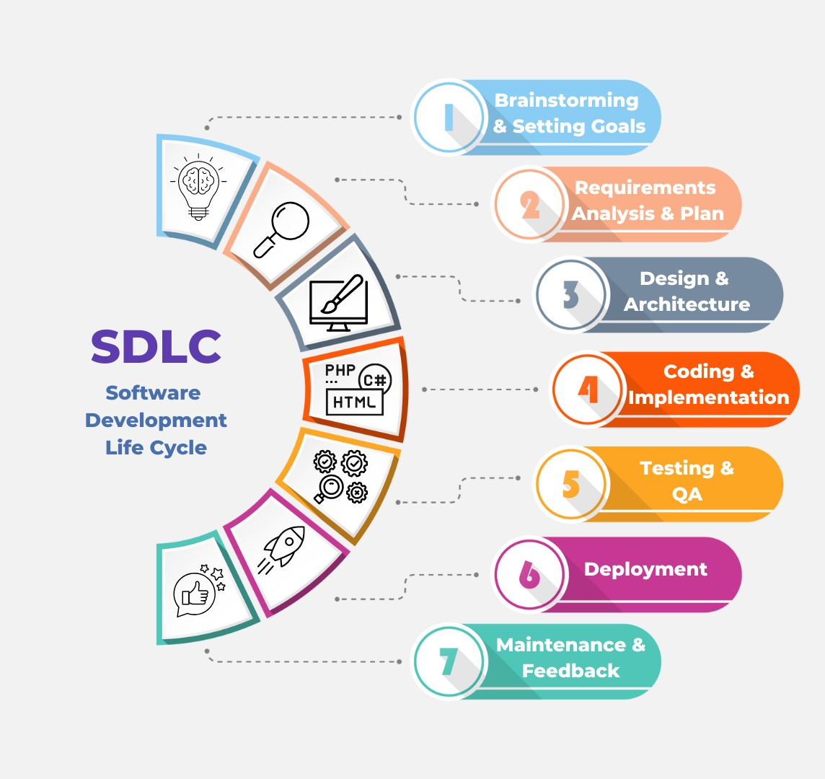

Figure 1: Software Development Life Cycle (SDLC).

Database design is the process of producing a detailed data model of database. And for that, first we give the use case diagram which required for the project:

## 3.6 Use Case Diagram:

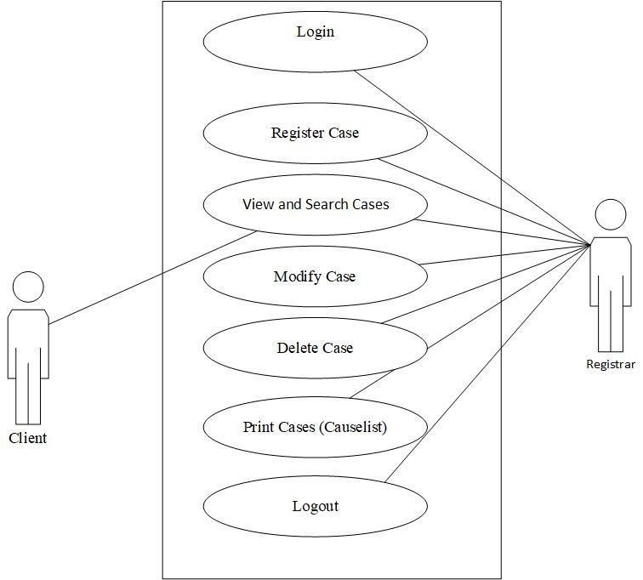

Figure 2: Use Case Diagram of Case Management System.

The first steps for the functional requirement collection are the use cases. Use cases are "a description of set of sequences of actions, including variants, that a system performs that yield an observable result of value to an actor".

## 3.7 Database ER Diagram (Schema Diagram)

The next step of the design phase is to draw a Database ER Diagram of the system. Since the programming language of the system is an object oriented one, a Database ER Diagram is particularly adapted to show the classes of the system, their inter relationships, and the operations and attributes of the classes.

Here is the class diagram of the project.

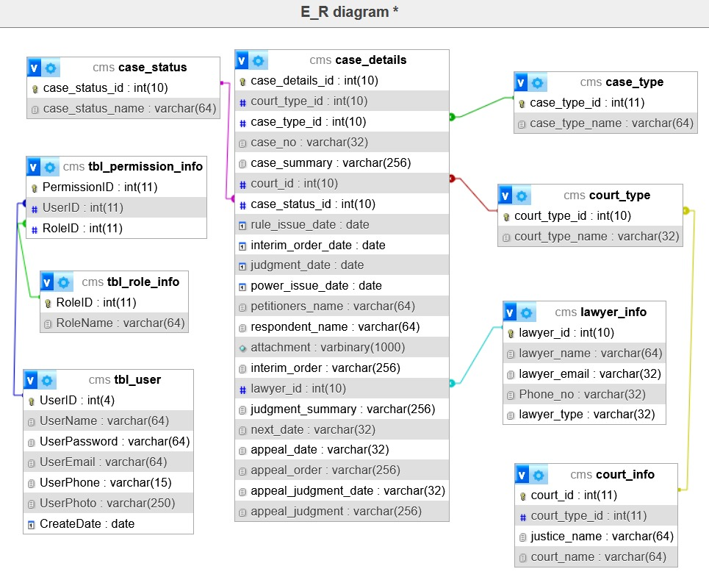

Figure 3: Entity Relationship (ER) Schema Diagram of Case Management System.

**Chapter-4**

System Design

# Chapter-4: System Design

## 4.1 Introduction

The [design phase](http://searchsoftwarequality.techtarget.com/definition/systems-development-life-cycle) is concerned with the physical construction of the system. Included are the design or configuration of the network (hardware, operating system, programming, etc.), design of user interfaces (forms, reports, etc.), design of system interfaces (for communication with other systems), and security issues. It is important that the proposed design be tested for performance, and to ensure that it meets the requirements outlined during the analysis phase. In other words, the main objective of this phase is to transform the previously defined requirements into a complete and detailed set of specifications which will be used during the next phase. Some of the activities that need to take place during the design phase are:

1. Design the application
2. Design and integrate the network
3. Design and integrate the database
4. Create a contingency plan
5. Start a Maintenance, Training and Operations plan
6. Review the design
7. Articulate the business processes and procedures
8. Establish a transition strategy
9. Deliver the System Design Document
10. Review final design

A database system is essentially nothing more than a computerized record keeping system the database itself can be regarded as kind of electronic filing cabinet. A database consists of same collection of some collection of persistent data that is used by the applications system of given some instituted. The term “instituted” here is simply a convenient generic term for any reasonable self- contained science, technical or other institution.

## 4.2 Database Design

A database management system (DBMS) is a collection of programs that enables you to [store](http://www.webopedia.com/TERM/S/store.html), modify, and extract information from a [database](http://www.webopedia.com/TERM/D/database.html). There are many different types of database management systems, ranging from small [systems](http://www.webopedia.com/TERM/S/system.html) that [run](http://www.webopedia.com/TERM/R/run.html) on personal computers to huge systems that run on [mainframes](http://www.webopedia.com/TERM/M/mainframe.html).

DBMS is a software that handles the storage, retrieval, and updating of data in a computer system. Example: Ex-SQL Server (Microsoft), MySQL (Freeware), Oracle (Oracle), NoSQL (Oracle), NonStop SQL (Hewlett Packard (Coronel, Carlos; Morris)).

## 4.3 System Architecture Design

A system architecture or systems architecture is the [conceptual model](http://en.wikipedia.org/wiki/Conceptual_model) that defines the [structure](http://en.wikipedia.org/wiki/Structure), [behavior](http://en.wikipedia.org/wiki/Behavior), and more [views](http://en.wikipedia.org/wiki/View_model) of a [system](http://en.wikipedia.org/wiki/System). An architecture description is a formal description and representation of a system, organized in a way that supports reasoning about the [structures](http://en.wikipedia.org/wiki/Structure) and [behaviors](http://en.wikipedia.org/wiki/Behavior) of the system.

System architecture can comprise system [components](http://en.wikipedia.org/wiki/System), the externally visible properties of those components, the relationships (e.g. the behavior) between them. It can provide a plan from which products can be procured, and systems developed, that will work together to implement the overall system. There have been efforts to formalize languages to describe system architecture, collectively these are called [architecture description languages](http://en.wikipedia.org/wiki/Architecture_description_languages).

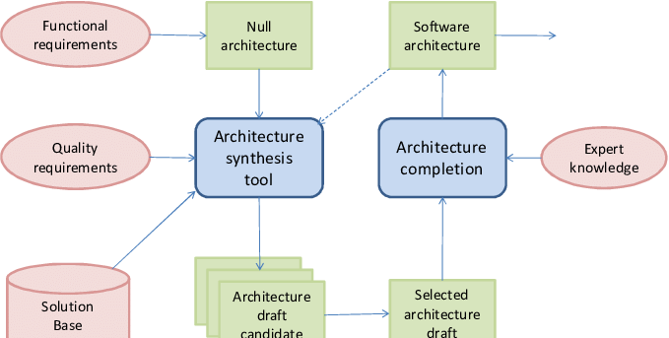

Figure 4: Software Architecture Design.

Software architecture refers to the high-level structures of a [software system](http://en.wikipedia.org/wiki/Software_system), the discipline of creating such structures, and the documentation of these structures. It is the set of structures needed to reason about the software system. Each structure comprises software elements, relations among them, and properties of both elements and relations. The architecture of a software system is a metaphor, analogous to the [architecture](http://en.wikipedia.org/wiki/Architecture) of a building (Ferreira, Pedro F.; Machado).

## 4.4 Code Design

Design patterns are solutions to software design problems you find again and again in real-world application development. Patterns are about reusable designs and interactions of objects.

The 23 Gang of Four (GoF) patterns are generally considered the foundation for all other patterns. They are categorized in three groups: Creational, Structural, and Behavioral (for a complete list see below).

To give you a head start, the PHP source code for each pattern is provided in 2 forms: structural and real-world. Structural code uses type names as defined in the pattern definition and UML diagrams. Real-world code provides real-world programming situations where you may use these patterns.

A third form, .NET optimized, demonstrates design patterns that fully exploit built-in .NET 4.5 features, such as, generics, attributes, delegates, reflection, and more. These and much more are available in our [.NET Design Pattern Framework 4.5](http://www.dofactory.com/products/net-design-pattern-framework).

This structural code demonstrates the Singleton pattern which assures only a single instance (the singleton) of the class can be created.

This real-world code demonstrates the Singleton pattern as a Load Balancing objects. Only a single instance (the singleton) of the class can be created because servers may dynamically come on-or off-line and every request must go through the one object that has knowledge about the state of the (web) farm (Pressman, Roger S.; Maxim).

**4.5 Implementation**

Implementation is the stage in the project where the theoretical design is turned into a working system and is giving confidence on the new system for the users that it will work efficiently and effectively. It involves careful planning, investigation of the current system and its constraints on implementation, design of methods to achieve the changeover, an evaluation of change over methods. Apart from planning major task of preparing the implementation are education and training of users. The more complex system being implemented, the more involved will be the system analysis and the design effort required just for implementation (Pressman, Roger S.; Maxim).

An implementation co-ordination committee based on policies of individual organization has been appointed. The implementation process begins with preparing a plan for the implementation of the system. According to this plan, the activities are to be carried out, discussions are made regarding the equipment and resources and the additional equipment has to be acquired to implement the new system.

Implementation is the final and important phase. This is the most critical stage it achieving a successful new system and in giving the users confidence that the new system will work is effective. The system can be implemented only after thorough testing. This method also offers the greatest security since the old system can take over if the errors are found or inability to handle certain type of transactions while using the new system.

**Chapter-5**

Coding Structure & Design

# Chapter–5: Coding Structure & Design

**Introduction of Coding Structure**

The system has mainly Six parts:

## 5.1 Major Parts and Dashboard

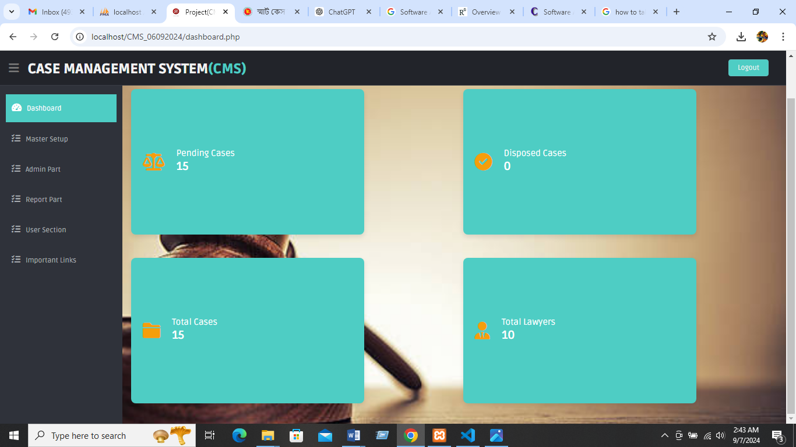Figure 5: Dashboard

## 

## 5.1.1 Admin User Login Form Design:

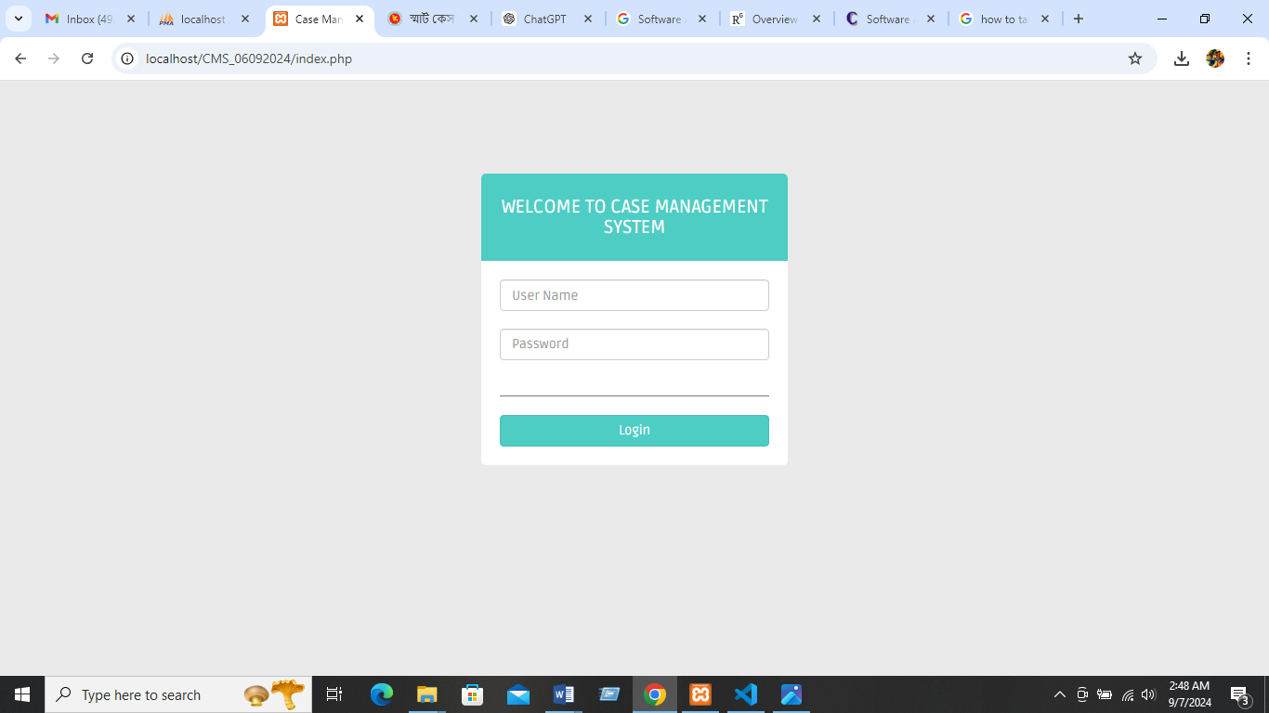

Figure 6: Login Form

**Code:**

**File: login.php (admin)**

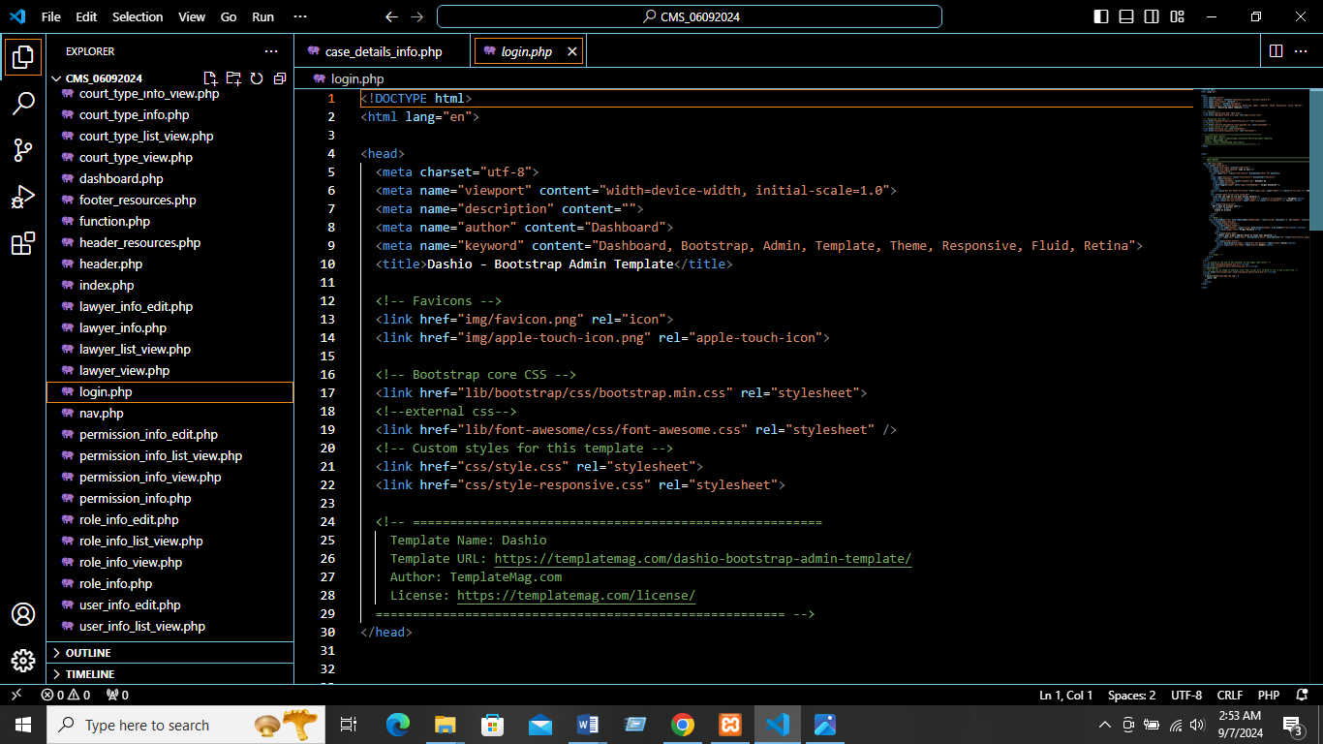

* + 1. **Master Setup: >> Court Type List View**

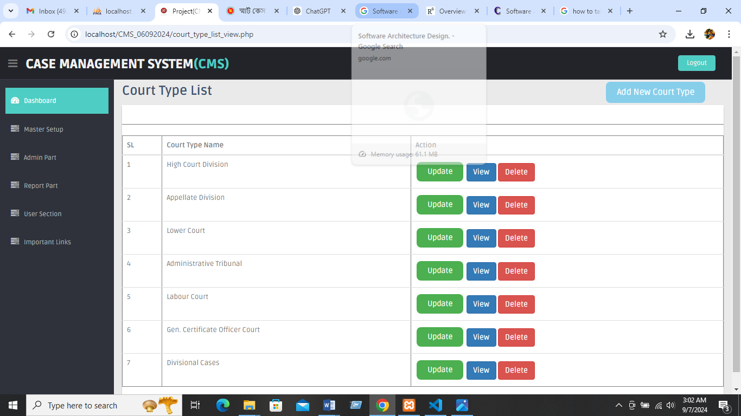

* + 1. **Master Setup: >> Case Status List View**

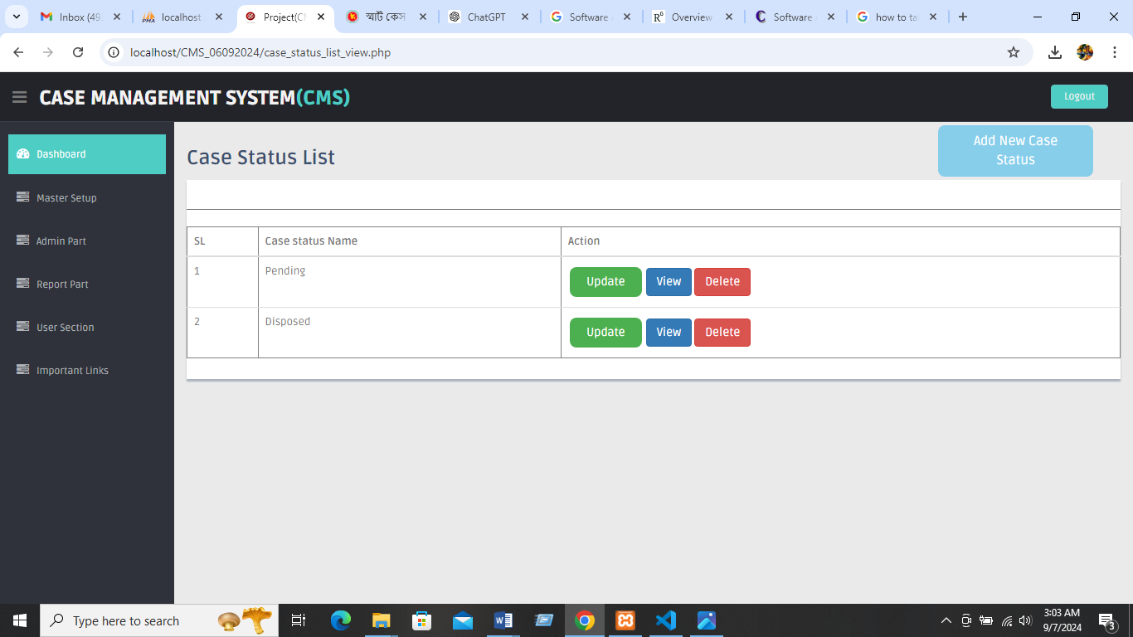

* + 1. **Master Setup: >> Lawyer List View**

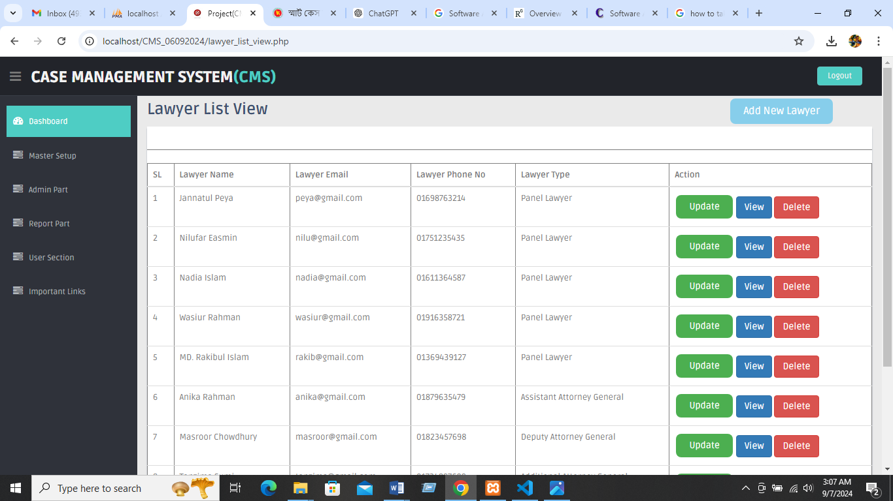

* + 1. **Master Setup: >> Case type List view**

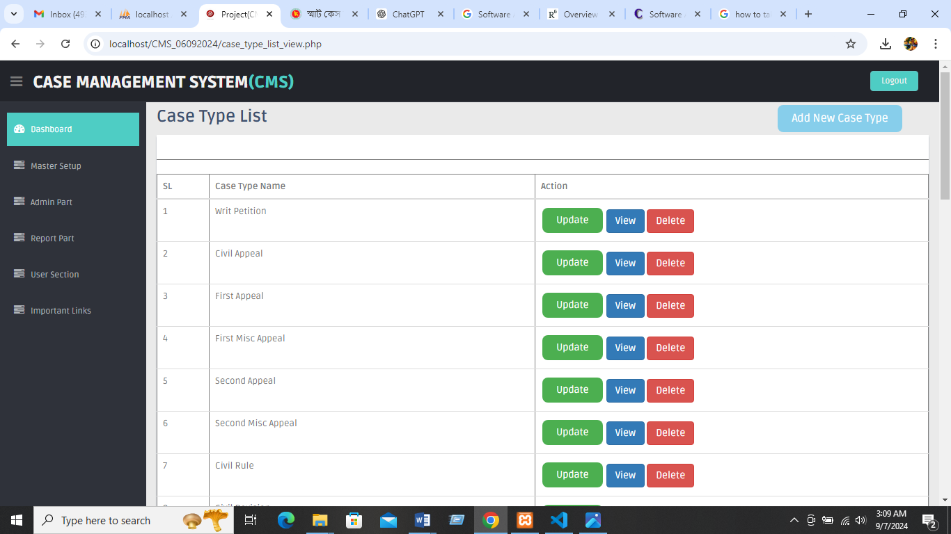

* + 1. **Master Setup >> Court Information List view**

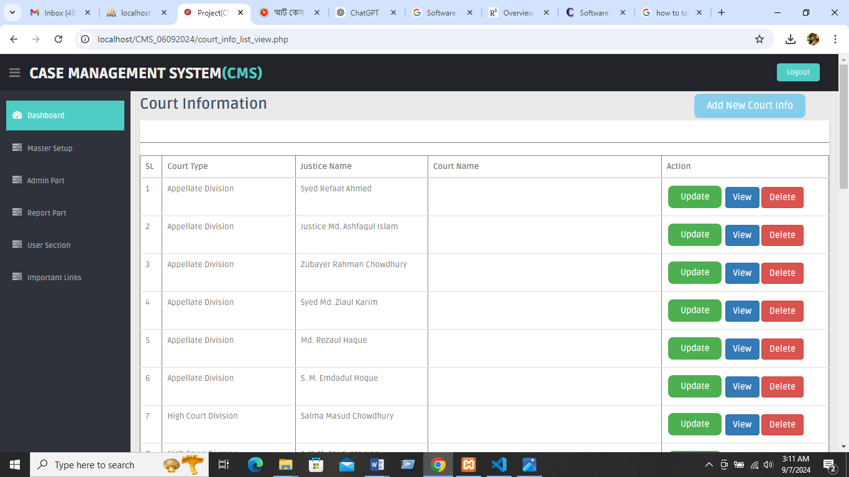

* + 1. **Admin Part >> Case Details List View**

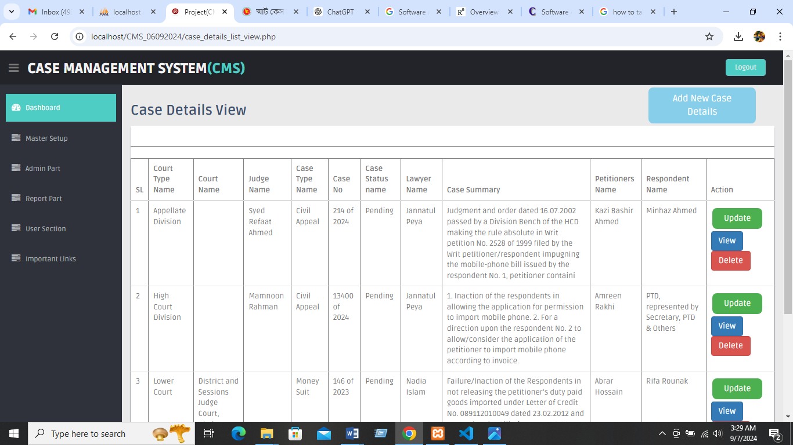

**Code:**

<!DOCTYPE html>

<html lang="en">

<?php

  include('connection.php');

include('function.php');

  $court_type_list          = court_type_list();

  $case_type_list           = case_type_list();

  $case_status_type_list    = case_status_type_list();

  $lawyer_list              =lawyer_list();

  $court_name_list          =court_name_list();

  $justice_name_list        =justice_name_list();

  if(isset($_POST['save']))

  {

$court_type_id        = $_POST['court_type_id'];

    $case_type_id         = $_POST['case_type_id'];

    $case_no              = $_POST['case_no'];

    $court_id             = $_POST['court_id'];

    $case_status_id       = $_POST['case_status_id'];

    $rule_issue_date      = $_POST['rule_issue_date'];

    $interim_order_date   = $_POST['interim_order_date'];

    $judgment_date        = $_POST['judgment_date'];

    $power_issue_date     = $_POST['power_issue_date'];

    $petitioners_name     = $_POST['petitioners_name'];

    $respondent_name      = $_POST['respondent_name'];

    $case_summary         = $_POST['case_summary'];

    $attachment           = $_POST['attachment'];

    $interim_order        = $_POST['interim_order'];

    $lawyer_id            = $_POST['lawyer_id'];

    $judgment_summary     = $_POST['judgment_summary'];

    $next_date            = $_POST['next_date'];

    $appeal_date          = $_POST['appeal_date'];

    $appeal_order         = $_POST['appeal_order'];

    $appeal_judgment_date = $_POST['appeal_judgment_date'];

    $appeal_judgment      = $_POST['appeal_judgment'];

    // Handling file upload

    $attachment = '';

    if (isset($_FILES['attachment']) && $_FILES['attachment']['error'] == 0) {

        $upload_dir = 'uploads/'; // Make sure this directory exists and is writable

        $upload_file = $upload_dir . basename($_FILES['attachment']['name']);

        $file_type = strtolower(pathinfo($upload_file, PATHINFO_EXTENSION));

        // Validate file type (e.g., allow only certain types of images)

        if (in_array($file_type, ['jpg', 'jpeg', 'png', 'gif'])) {

            if (move_uploaded_file($_FILES['attachment']['tmp_name'], $upload_file)) {

                $attachment = basename($_FILES['attachment']['name']);

            } else {

                echo "Error uploading file.";

                exit;

            }

        } else {

            echo "Invalid file type.";

            exit;

        }

    }

$sql = "insert into  case_details (court_type_id, case_type_id, case_no, court_id, case_status_id, rule_issue_date, interim_order_date,judgment_date, power_issue_date,petitioners_name,respondent_name,case_summary,attachment,interim_order,lawyer_id,judgment_summary,next_date,Appeal_date,Appeal_order,appeal_judgment_date,appeal_judgment) values

 ('$court_type_id','$case_type_id','$case_no','$court_id','$case_status_id','$rule_issue_date','$interim_order_date','$judgment_date','$power_issue_date','$petitioners_name','$respondent_name','$case_summary','$attachment','$interim_order','$lawyer_id','$judgment_summary','$next_date','$appeal_date','$appeal_order','$appeal_judgment_date','$appeal_judgment')";

  //echo  $sql;

  //die;

    $result = $conn->query($sql);

    if($result == 1)

    {

      echo "Successfully Inserted!";

      header("Location:case_details_list_view.php");

    }

  }

?>

<head>

  <?php  include('header_resources.php');   ?>

</head>

<body>

  <section id="container">

    <?php

    include('header.php');

    include('nav.php');

    ?>

    <!--main content start-->

    <section id="main-content">

      <section class="wrapper">

        <h3> Case Details Information</h3>

        <!-- BASIC FORM ELELEMNTS -->

        <div class="row mt">

          <div class="col-lg-12">

            <div class="form-panel">

              <form class="form-horizontal style-form" action="case_details_info.php" method="post" enctype="multipart/form-data">

  <div class="form-group">

        <label class="col-sm-2 col-sm-2 control-label">Court Type Name</label>

    <div class="col-sm-6">

    select name="court_type_id" id="court_type_id" onClick="change_fuc();" style="height:30px; width:600px;">

   <option value='0'>------------Select Any Option----------------</option>

                      <?php

                        foreach($court_type_list as $key => $value)

                        {

                          echo "<option value='$key'>$value</option>";

                        }

                      ?>

                  </select>

                  </div>

                </div>

                <div class="form-group">

                  <label class="col-sm-2 col-sm-2 control-label">Court Name</label>

                  <div class="col-sm-6">

                  <select name="court_id" id="court_name" style="height:30px; width:600px;">

                    <option value='0'>------------Select Any Option----------------</option>

                      <?php

                        foreach($court_name_list as $key => $value)

                        {

                          echo "<option value='$key'>$value</option>";

                        }

                      ?>

                  </select>

                  </div>

                </div>

                <div class="form-group">

                  <label class="col-sm-2 col-sm-2 control-label">Justice Name</label>

                  <div class="col-sm-6">

                  <select name="court_id" id="justice_name" style="height:30px; width:600px;">

                    <option value='0'>------------Select Any Option----------------</option>

                      <?php

                        foreach($justice_name_list as $key => $value)

                        {

                          echo "<option value='$key'>$value</option>";

                        }

                      ?>

                  </select>

                  </div>

                </div>

   <div class="form-group">

      <label class="col-sm-2 col-sm-2 control-label">Case Type Name</label>

       <div class="col-sm-6">

 <select name="case_type_id" id="case_type_id" onClick="change_fuc();" style="height:30px; width:600px;">

                    <option value='0'>------------Select Any Option----------------</option>

                      <?php

                        foreach($case_type_list as $key => $value)

                        {

                          echo "<option value='$key'>$value</option>";

                        }

                      ?>

                  </select>

                  </div>

                </div>

     <div class="form-group">

     <label class="col-sm-2 col-sm-2 control-label">Case No</label>

                  <div class="col-sm-6">

                    <input type="text" name="case_no" class="form-control">

                  </div>

                  </div>

                  <div class="form-group">

          <label class="col-sm-2 col-sm-2 control-label">Case Summary</label>

                  <div class="col-sm-6">

                 <input type="text" name="case_summary" class="form-control">

                  </div>

                  </div>

                  <div class="form-group">

      <label class="col-sm-2 col-sm-2 control-label">Petitioners Name</label>

       <div class="col-sm-6">

      <input type="text" name="petitioners_name" class="form-control">

                  </div>

                  </div>

<div class="form-group">

<label class="col-sm-2 col-sm-2 control-label">Respondent name</label>

  <div class="col-sm-6">

 <input type="text" name="respondent_name" class="form-control">

                  </div>

</<div class="form-group">

 <label class="col-sm-2 col-sm-2 control-label">Rule Issue Date</label><div class="col-sm-6">

<input type="date" name="rule_issue_date" class="form-control">

                  </div>

                </div>

  <div class="form-group">

  <label class="col-sm-2 col-sm-2 control-label">Attachment</label>

  <div class="col-sm-6">

   <input type="file" name="attachment" class="form-control">

                  </div>

                  </div>

<div class="form-group">

<label class="col-sm-2 col-sm-2 control-label">Interim Order Date</label>

<div class="col-sm-6"><input type="date" name="interim_order_date" class="form-control">

                  </div>

                  </div>

 <div class="form-group">

  <label class="col-sm-2 col-sm-2 control-label">Interim Order</label>

   <div class="col-sm-6"

<input type="text" name="interim_order" class="form-control">

                  </div>

                  </div>

 <div class="form-group">

  <label class="col-sm-2 col-sm-2 control-label">Lawyer Name</label>

   <div class="col-sm-6">

   <select name="lawyer_id" id="lawyer_id" onClick="change_fuc();" style="height:30px; width:600px;">

 <option value='0'>------------Select Any Option----------------</option>

                      <?php

                        foreach($lawyer_list as $key => $value)

                        {

                          echo "<option value='$key'>$value</option>";

                        }

                      ?>

                  </select>

                  </div>

                </div>

<div class="form-group">

<label class="col-sm-2 col-sm-2 control-label">Power Issue Date</label>

<div class="col-sm-6">

<input type="date" name="power_issue_date" class="form-control">

                  </div>

                  </div>

                  <div class="form-group">

                  <label class="col-sm-2 col-sm-2 control-label">Case Status Name</label>

                  <div class="col-sm-6">

                  <select name="case_status_id" id="case_status_id" onClick="change_fuc();" style="height:30px; width:600px;">

                    <option value='0'>------------Select Any Option----------------</option>

                      <?php

                        foreach($case_status_type_list as $key => $value)

                        {

        echo "<option value='$key'>$value</option>";

                        }

                      ?>

                  </select>

                  </div>

                </div>

              <div class="form-group">

                  <label class="col-sm-2 col-sm-2 control-label">Next Date</label>

                  <div class="col-sm-6">

                    <input type="date" name="next_date" class="form-control">

                  </div>

                  </div>

<div class="form-group">

  <label class="col-sm-2 col-sm-2 control-label">Judgement Date</label>

     <div class="col-sm-6">

       <input type="date" name="judgment_date" class="form-control">

                  </div>

                  </div>

                  <div class="form-group">

   <label class="col-sm-2 col-sm-2 control-label">Judgement Summary</label>

   <div class="col-sm-6">

    <input type="text" name="judgment_summary" class="form-control">

                  </div>

                  </div>

<div class="form-group">

  <label class="col-sm-2 col-sm-2 control-label">Appeal Date</label>

   <div class="col-sm-6">

  <input type="date" name="appeal_date" class="form-control">

                  </div>

                  </div>

<div class="form-group">

  <label class="col-sm-2 col-sm-2 control-label">Appeal Order</label>

  <div class="col-sm-6">

<input type="text" name="appeal_order" class="form-control">

                  </div>

                  </div>

<div class="form-group">

<label class="col-sm-2 col-sm-2 control-label">Appeal Judgment Date</label>

  <div class="col-sm-6">

   <input type="date" name="appeal_judgment_date" class="form-control">

                  </div>

                  </div>

<div class="form-group">

   <label class="col-sm-2 col-sm-2 control-label">Appeal Judgment</label>

    <div class="col-sm-6">

               <input type="text" name="appeal_judgment" class="form-control">

                  </div>

                  </div>

        <div class="form-group">

                  <div class="col-sm-8" align="center">

                    <input type="submit" name="save" class="btn btn-info">

                  </div>

                </div>

              </form>

            </div>

          </div>

          <!-- col-lg-12-->

        </div>

        <!-- /row -->

      </section>

      <!-- /wrapper -->

    </section>

    <!-- /MAIN CONTENT -->

    <!--main content end-->

    <!--footer start-->

    <!--footer end-->

  </section>

  <?php   include('footer_resources.php');  ?>

</body>

<script>

    function change_fuc()

    {

      const myElement = document.getElementById("court_type_id").value;

      if(myElement == 1 || myElement == 2)

      {

        document.getElementById("court_name").disabled = true;

        document.getElementById("justice_name").disabled = false;

        document.getElementById("court_name").value = "";

      }else{

        document.getElementById("justice_name").disabled = true;

        document.getElementById("court_name").disabled = false;

        document.getElementById("justice_name").value = "";

      }

            //alert(myElement);

    }

  </script>

</html>

* + 1. **User Role List View**

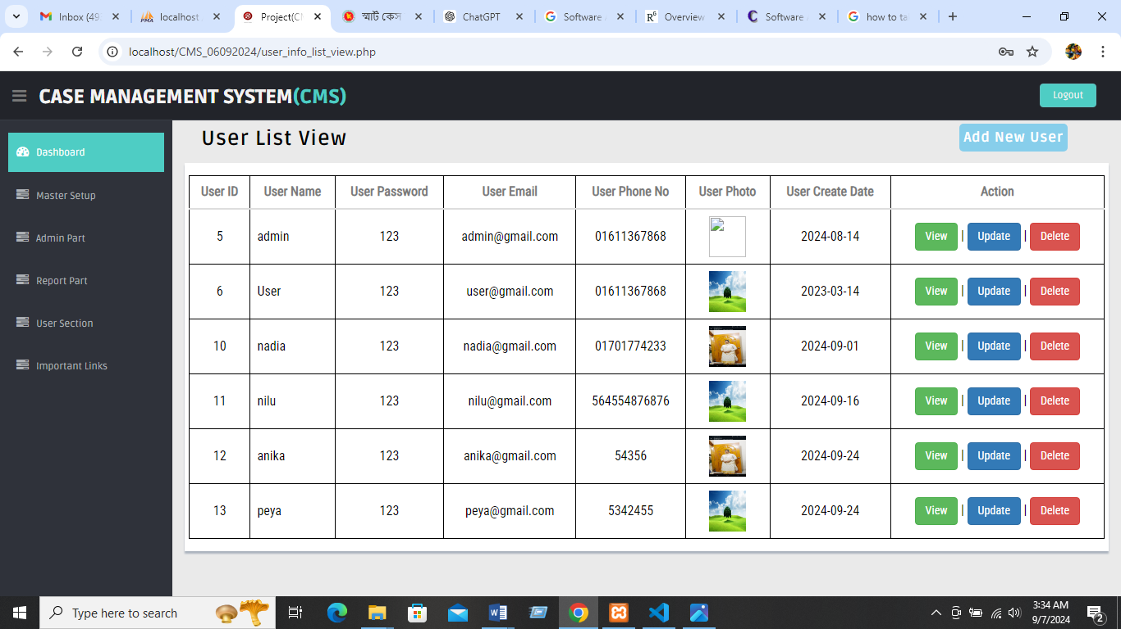

* + 1. **User-wise Permission List View**

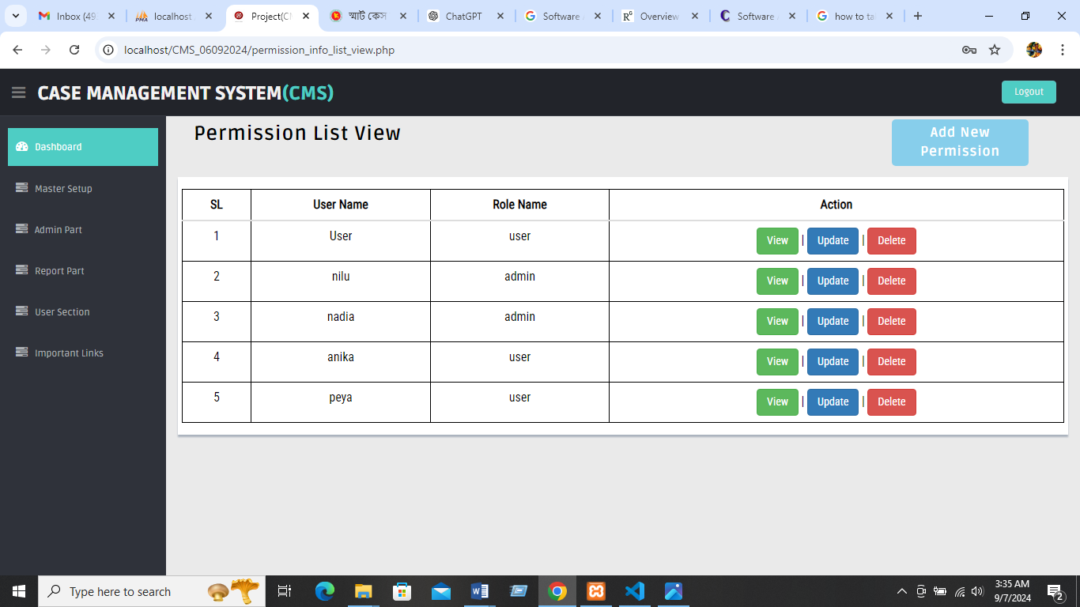

## Report Part

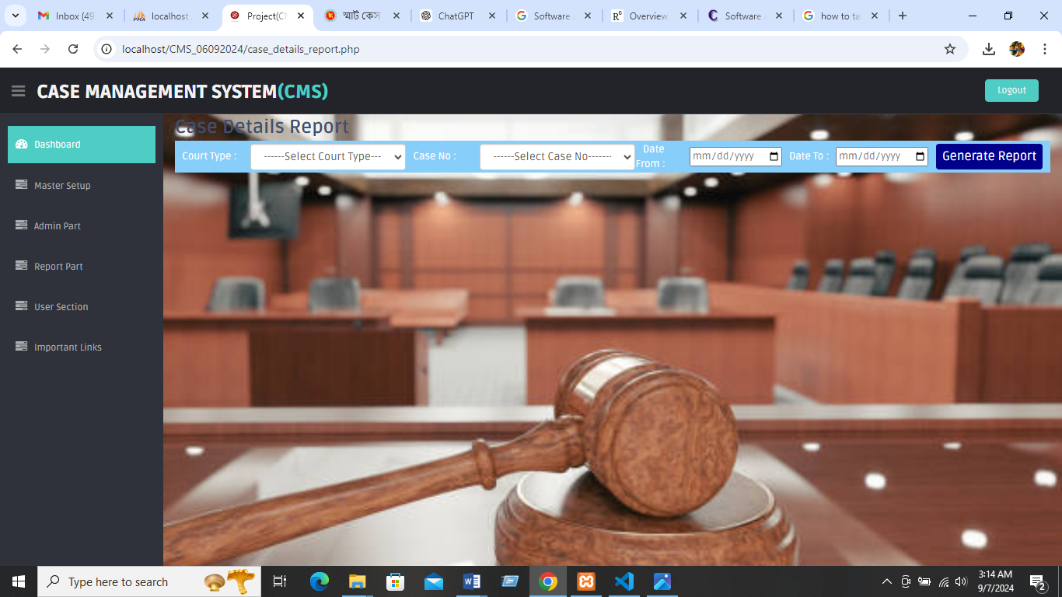

* + 1. **Court Type-Wise Report**

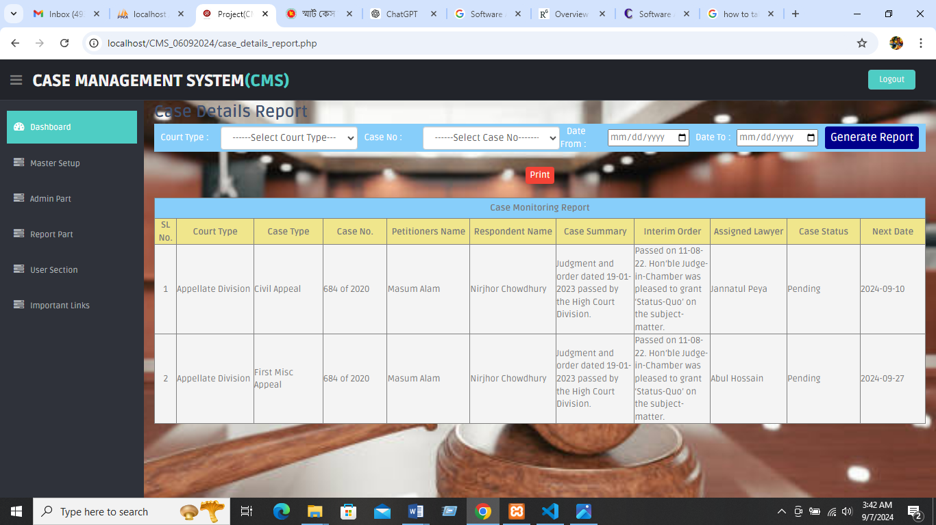

* + 1. **Court Type-Wise Report print view**

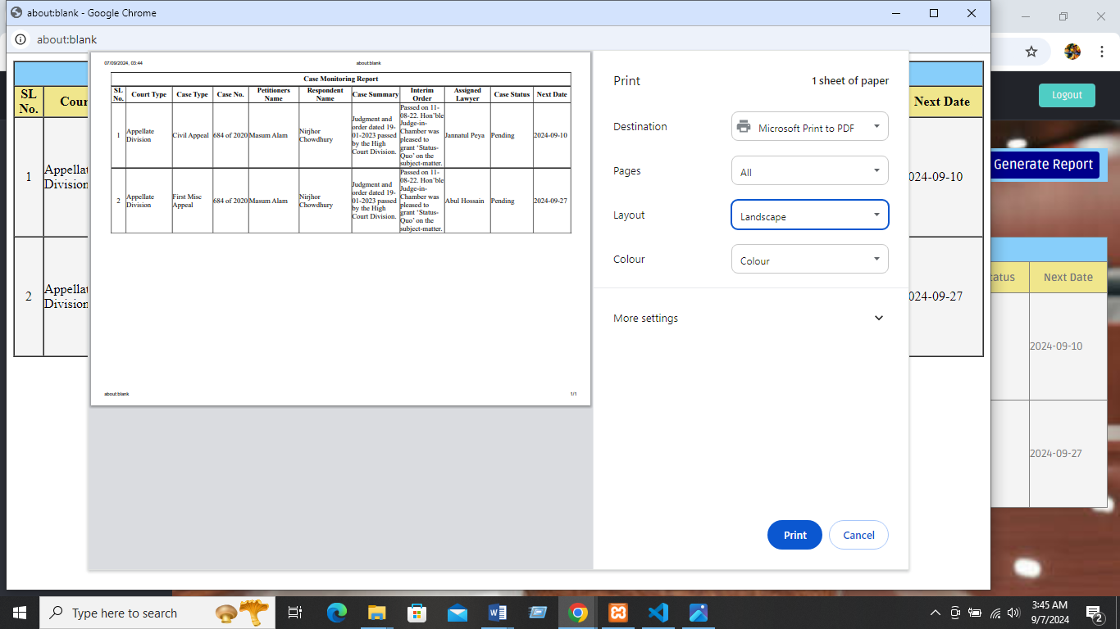

* + 1. **Case No-wise Report**

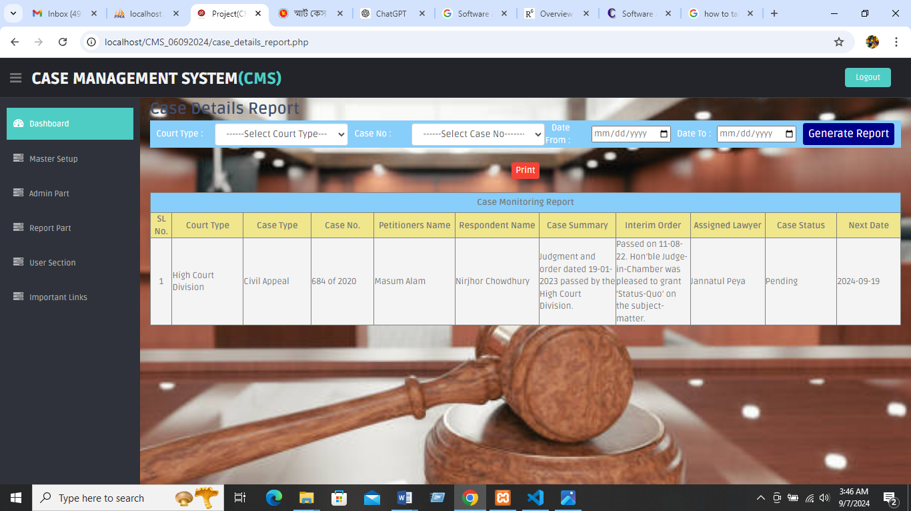

* + 1. **Date Range-wise Report**

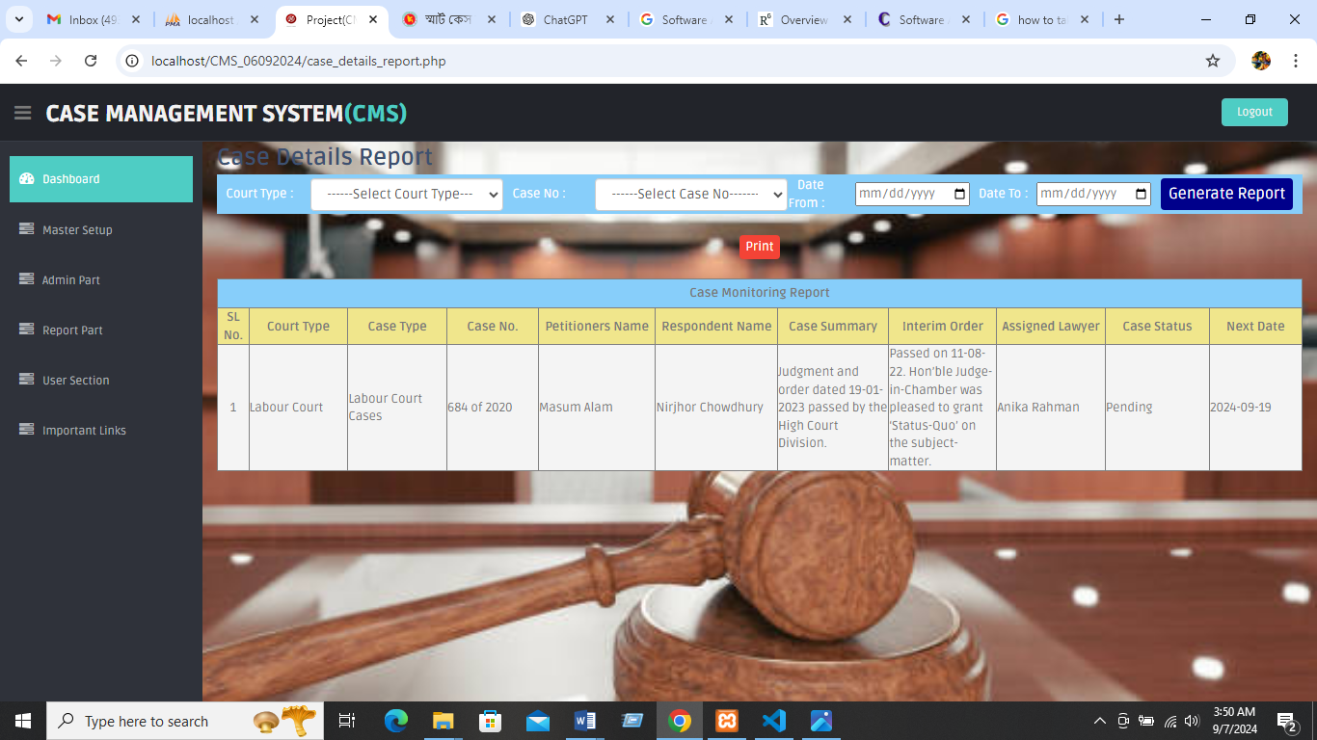

* 1. **Important Links**

Some important links are also included in this software for quick access i.e. <https://www.supremecourt.gov.bd/>, <https://judiciary.gov.bd/>, <http://bdlaws.minlaw.gov.bd/> and <https://attorneygeneral.gov.bd/>.

**Chapter-6**

Database Table Design

# Chapter-6: Database Table Design

## 6.1 XAMPP Server Database Table Design View

In XAMPP Server we created a database for our Project named ‘cms’. This database will contain all the data of Case Management System (backend) and Website (frontend).

* 1. **Open a Connection to MySQL database**

Before we can access data in the MySQL database, we need to be able to connect to the server:

|  |
| --- |
| <?php  $servername = "localhost";  $username = "root";  $password = "";  $dbname = "cms";  $conn = new mysqli($servername, $username, $password, $dbname);?> |

## Case Management System Database Table Design

There are Nine (09) tables has been created so far in our Case Management System database. They are:

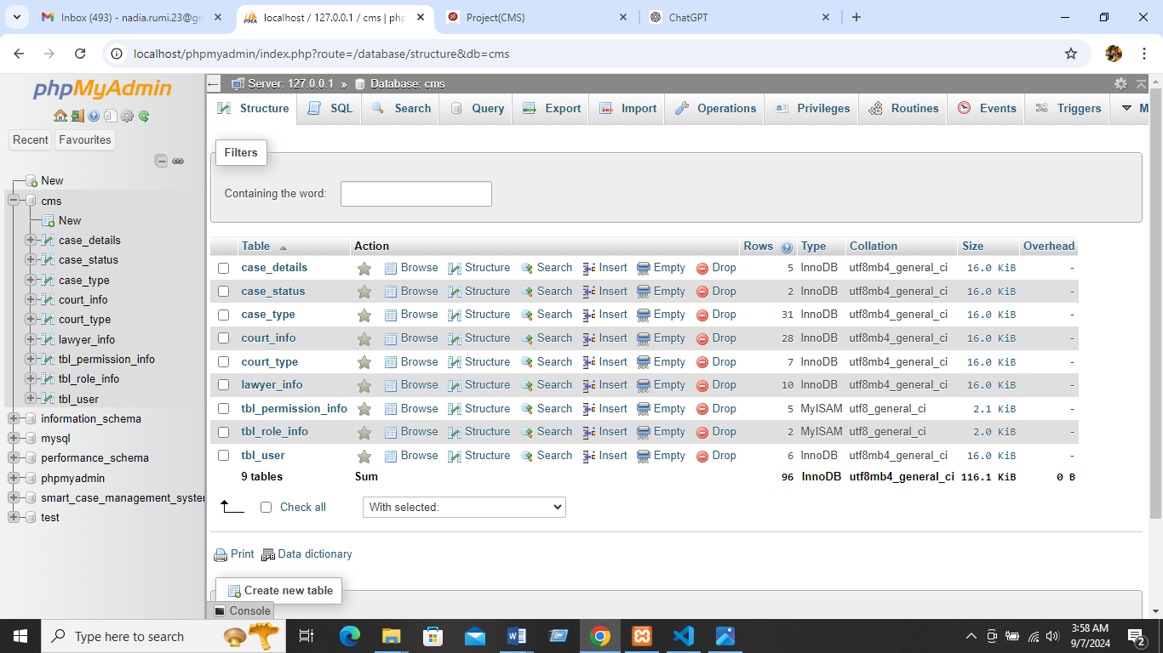

Here is the above-mentioned the phpMyAdmin interface of the database (Case Management System) where all tables are shown:

* 1. **Case Details Table Design**

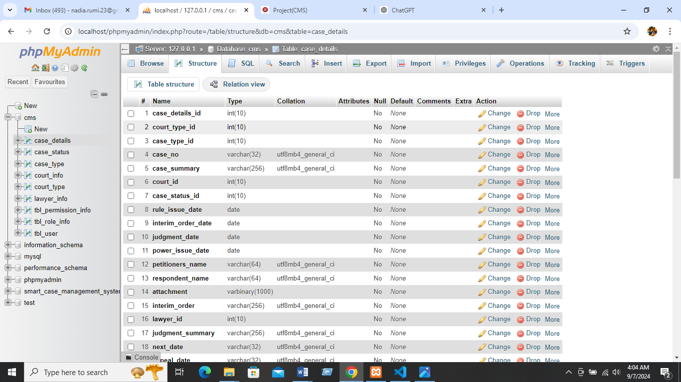

* 1. **Case Status Table Design**

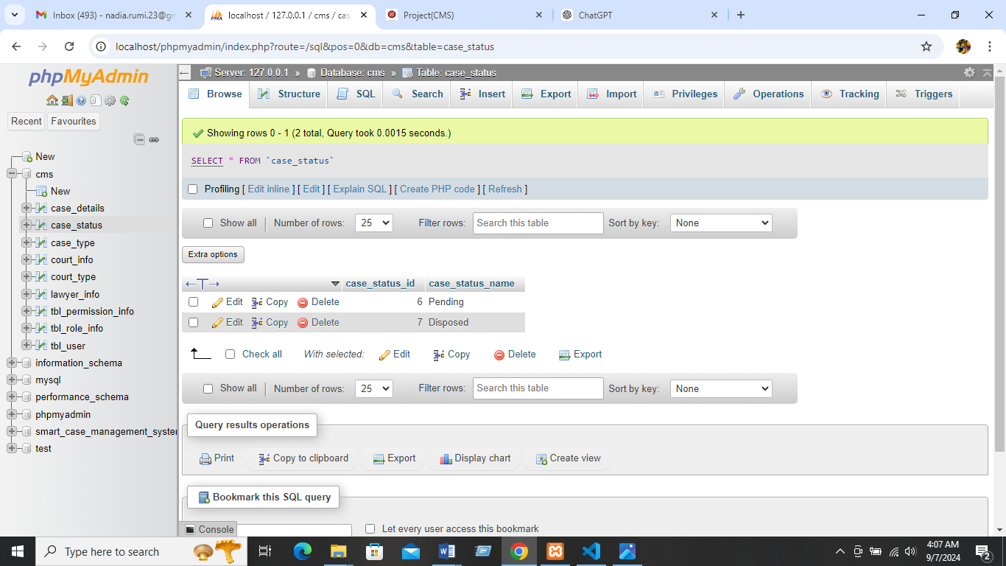

* 1. **Case type Table Design**

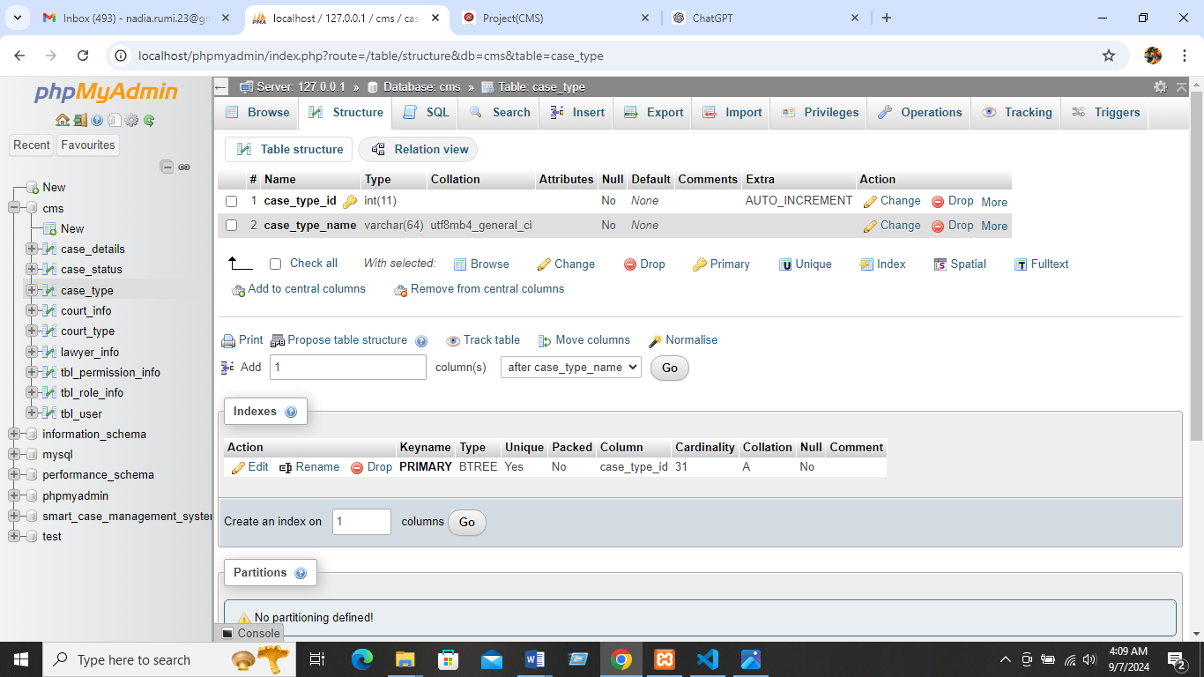

## 6.7 Court Info Table Design

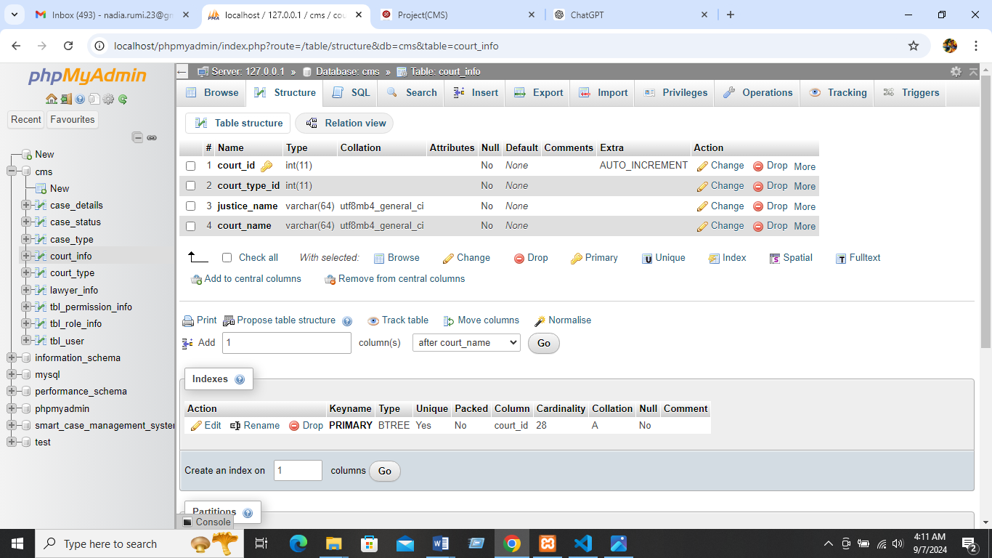

## 6.8 Court type Table Design

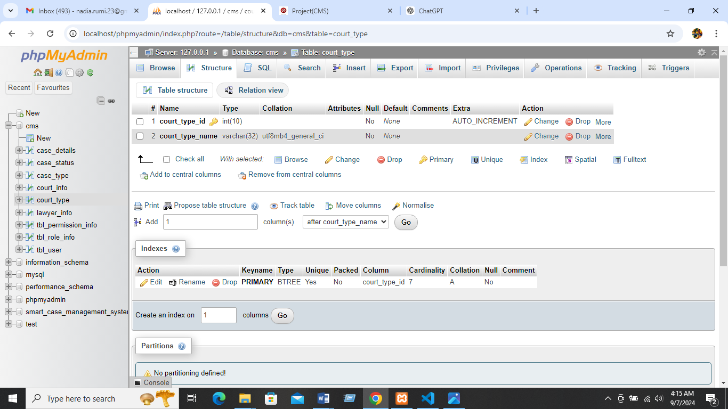

**6.9 Lawyer Info Table Design**

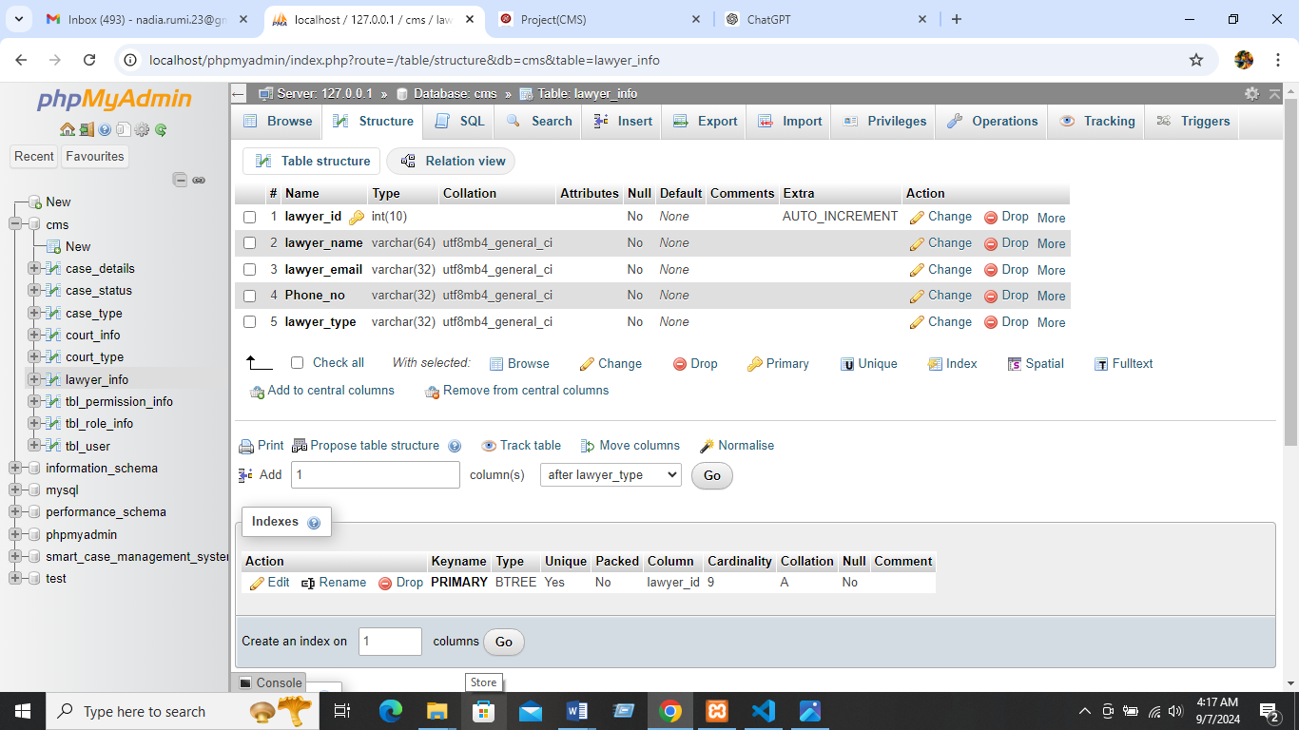

## 6.10 Permission info table Design

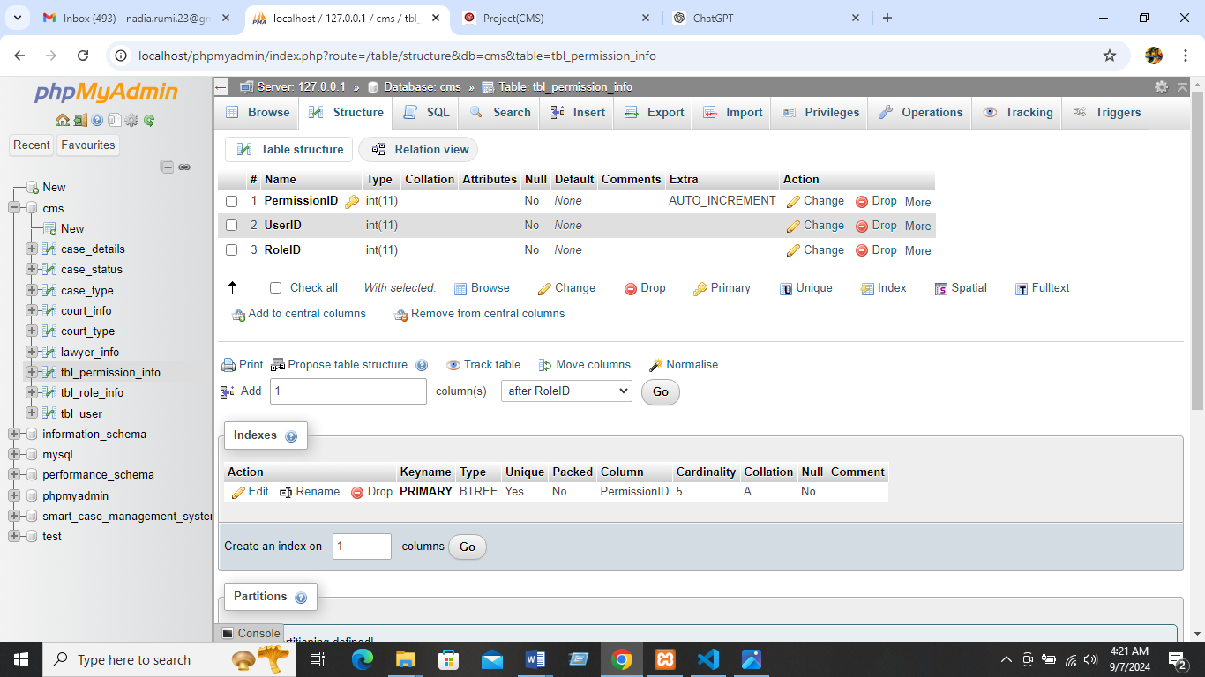

## 

## 6.11 Role info table Design

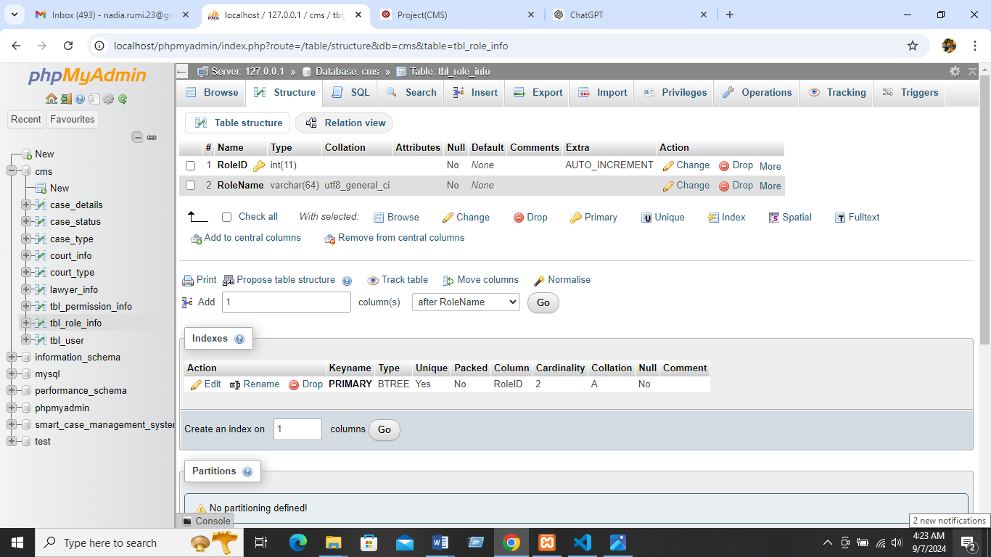

## 

## 6.12 User info table Design

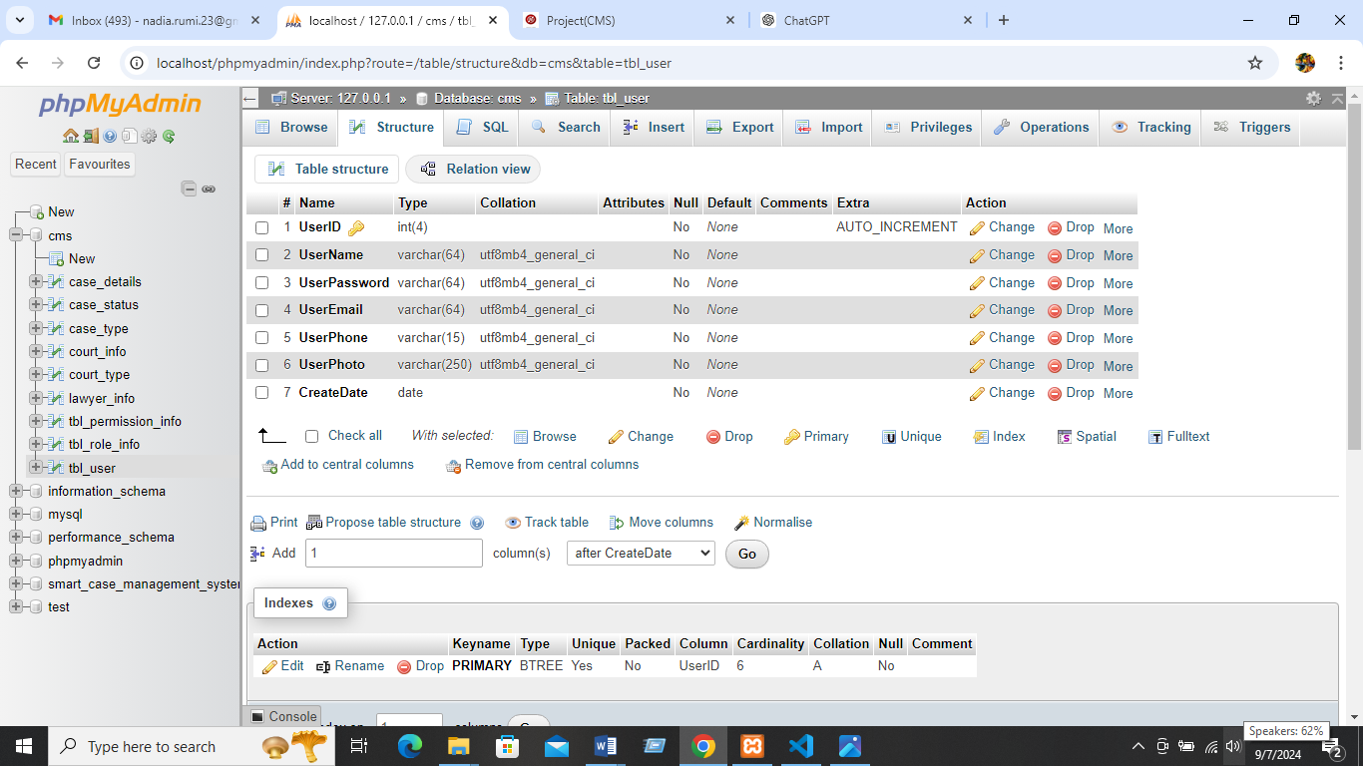

## 6.13 PHP MySQL Database

With PHP, we can connect to and manipulate databases. MySQL is the most popular database system used with PHP.

* MySQL is a database system used on the web;
* MySQL is a database system that runs on a server;
* MySQL is ideal for both small and large applications;
* MySQL is very fast, reliable, and easy to use;
* MySQL uses standard SQL;
* MySQL compiles on a number of platforms;
* MySQL is free to download and use;
* MySQL is developed, distributed, and supported by Oracle Corporation.

The data in a MySQL database are stored in tables. A table is a collection of related data, and it consists of columns and rows. Databases are useful for storing information categorically (Welling, Luke; Thomson).

Here are some syntax rules to follow:

* The SQL query must be quoted in PHP;
* String values inside the SQL query must be quoted;
* Numeric values must not be quoted;
* The word NULL must not be quoted.

## 6.14 PHP + MySQL Database System

PHP combined with MySQL are cross-platform (you can develop in Windows and serve on a Unix platform) (Welling, Luke; Thomson).

## 6.15 Database Queries:

A query is a question or a request.

We can query a database for specific information and have a record set returned.

Look at the following query (using standard SQL):

SELECT lawyer_name FROM lawyer_info;

The query above selects all the data in the " lawyer_name" column from the "lawyer_info" table.

**Chapter-7**

Application Testing

# Chapter-7: Application Testing

## 7.1 Introduction

Software testing is the process of executing a program with intension of finding errors in the code. It is a process of evolution of system or its parts by manual or automatic means to verify that it is satisfying specified or requirements or not. Generally, system is perfect due to communication problems between user and developer, time constraints or conceptual mistakes by developer. The purpose of system testing is to check and find out these errors or faults as early as possible so losses due to it can be saved. Testing is the fundamental process of software success.

Testing is not a distinct phase in system development life cycle but should be applicable throughout all phases i.e. design development and maintenance phase. Testing is used to show incorrectness and considered to success when an error is detected.

## 7.2 Objectives of Software Testing

The software testing is usually performed for the following objectives:

* **Software Quality Improvement:** The computer and the software are mainly used for complex and critical applications and a bug or fault in software causes severe losses. So, great consideration is required for checking for quality of software.
* **Verification & Validation:** Verification means to test that we are building the product in right way i.e. are we using the correct procedure for the development of software so that it can meet the user requirements. Validation in means to check whether we are building the right product or not.
* **Software Reliability Estimation:** The objective is to discover the residual designing errors before delivery to the customer. The failure data during process are taken down in order to estimate the software reliability (Paul C. Jorgensen).

## 7.3 Principles of Software Testing

Software testing is an extremely creative and challenging task. Some important principles of software testing are as given: - All tests should be traceable to Customer requirements. Testing time and resources should be limited i.e. avoid redundant testing. It is impossible to test everything. Use effective resources to test. Test should be planned long before testing begins i.e. after requirement phase. Test for invalid and unexpected input conditions as well as valid conditions. Testing should begin in "in the small" and progress towards testing in the large". For the most effective testing should be conducted by an independent party. Keep software static (without change meanwhile) during test. Document test cases and test results. Examining what the software not doing which it expected to do and also checking what it is doing that was not expected to do(Paul C. Jorgensen).

## 7.4 Strategy for Software Testing

Different levels of testing are used in the test process each level of testing aims to test different aspects of the system. The first level is unit testing. In this testing 29 individual components are tested to ensure that they operate correctly. It focuses on verification efforts. The second level is integration testing. It is a systematic technique for constructing the program structure. In this testing, many tested modules are combined into the subsystem which is then tested. The good here is to see if the modules can be integrated properly. Third level is integration testing. System testing is actually a series of different tests whose primary purpose is to fully exercise computer-based system. These tests fall outside scope of software process and are not conducted solely by software engineers.

* **Black Box Testing:** Black box testing is a testing technique that ignores the internal mechanism of the system and focuses on the output generated against any input and execution of the system. It is also called functional testing (Tim Koomen)
* **White Box Testing:** White box testing is a testing technique that takes into account the internal mechanism of a system. It is also called structural testing and glass box testing. Black box testing is often used for validation and white box testing is often used for Verification (P. C. Jorgensen).
* **Unit Testing:** The software units in a system are modules and routines that are assembled and integrated to perform a specific function. Unit testing focuses first on modules, independently of one another, to locate errors. This enables, to detect errors in coding and logic that are contained within each module. This testing includes entering data and ascertaining if the value matches to the type and size supported by java. The various controls are tested to ensure that each performs its action as required (Paul C. Jorgensen).
* **Integration Testing:** Data can be lost across any interface, one module can have an adverse effect on another, sub functions when combined, may float produce the desired major functions. Integration testing is a systematic testing to discover errors associated within the interface. The objective is to take unit tested modules and build a program structure. All the modules are combined and tested as a whole (M. Ramachandran, S. Muthuvelayutham).
* Here the Server Module and Client module options are integrated and tested. This testing provides the assurance that the application is well integrated functional unit with smooth transition of data (Paul C. Jorgensen) .
* **Functional Testing:** Functional testing is the testing to ensure that the specified functionality required in the system requirements works. It falls under the class of black box testing (Paul C. Jorgensen).
* **System Testing:** System testing is the testing to ensure that by putting the software in different environments (e.g., Operating Systems) it still works. System testing is done with full system implementation and environment. It falls under the class of black box testing (Paul C. Jorgensen).
* **Stress Testing:** Stress testing is the testing to evaluate how system behaves under unfavorable conditions. Testing is conducted at beyond limits of the specifications. It falls under the class of black box testing.
* **Performance Testing:** Performance testing is the testing to assess the speed and effectiveness of the system and to make sure it is generating results within a specified time as in performance requirements. It falls under the class of black box testing.
* **Usability Testing:** Usability testing is performed to the perspective of the client, to evaluate how the GUI is user-friendly? How easily can the client learn? After learning how to use, how proficiently can the client perform? How pleasing is it to use its design? This falls under the class of black box testing.
* **Acceptance Testing:** Acceptance testing is often done by the customer to ensure that the delivered product meets the requirements and works as the customer expected. It falls under the class of black box testing (Paul C. Jorgensen).
* **Regression Testing:** Regression testing is the testing after modification of a system, component, or a group of related units to ensure that the modification is working correctly and is not damaging or imposing other modules to produce unexpected results. It falls under the class of black box testing (Paul C. Jorgensen).

**Chapter-8**

Future Works Development

# Chapter-8: Future Works Development

## 8.1 Introduction

In this project I have represented an efficient way of developing dynamic website by using power of PHP and My SQL. Still few limitations exist in the software; my aim is to develop this web site up to highly useful.

On this topic further study may be needed for more development. To make it global, easier and dynamic following study can be made:

Develop it for dynamic use not only used by internet, also by mobile communication

every user transaction can be possible by online and confirmation also possible by online system every user of the whole world can get help from this site.

## 8.2 List of Future Works Development:

1. Advanced Analytics and Predictive Insights
2. IoT (Internet of Things) Integration
3. Mobile Applications and Remote Access
4. Supply Chain Integration
5. Blockchain for Traceability and Transparency
6. Continuous Improvement and Innovation
7. Scalability and Global Expansion
8. Website Security Check
9. Invoice Emailer
10. Email & Mobile verification
11. Overall design development and bug fix
12. User Database Re-Design, User Role Implementation

**Chapter-9**

Conclusion

# Chapter-9: Conclusion

The development and implementation of a Case Management System (CMS) represent a significant advancement in the efficiency and effectiveness of Organizations. As outlined in this project paper, the proposed CMS addresses critical challenges faced by the court or administrative Personnel, including inefficiencies in case handling, lack of transparency, data management issues, and integration difficulties.

The successful deployment of the CMS will require careful planning and execution, including detailed requirement analysis, system design, and development. Adequate training for users and administrators is essential to ensure smooth adoption and utilization of the system. Ongoing support and maintenance will be crucial to address any issues and incorporate user feedback for continuous improvement.

In conclusion, the proposed Court Case Management System offers a transformative solution to the challenges faced by the different organizations. By adopting this system, courts can significantly improve their operational efficiency, ensure better transparency and accountability, and ultimately enhance the delivery of justice. The successful implementation of the CMS will set a precedent for modernizing judicial functional systems and pave the way for future advancements in court case management.

Top of Form

Bottom of Form

**References**

# References:

**Books and Academic Journals**

"Court Management: A Comprehensive Guide" by John W. R. Clegg and Jonathan P. A. Gill

"Information Technology for Management: Transforming Organizations in the Digital Economy" by Efraim Turban, Linda Volonino

"Managing and Improving Process Performance in Court Systems" by M. S. S. White and G. J. Morris

"E-Justice: The Role of Technology in the Courtroom" by Richard Susskind

"Database Systems: The Complete Book" by Hector Garcia-Molina, Jeffrey D. Ullman, Jennifer Widom

**Technical Papers and Articles**

"Design and Implementation of an E-Court Case Management System" by L. Yang and X. Zhang, *International Journal of Information Technology & Decision Making*, 2020.

"Case Management in E-Government: Design Principles for a Case Management System" by J. P. B. Hughes and R. A. Johnson, *Journal of E-Government Research*, 2021.

"Challenges and Solutions in Court Case Management Systems" by N. K. Prasad and R. Sharma, *Journal of Legal Technology*, 2019.

**Standards and Guidelines**

"ISO/IEC 27001:2013 - Information Security Management Systems" by International Organization for Standardization

"NIST Special Publication 800-53: Security and Privacy Controls for Information Systems and Organizations" by National Institute of Standards and Technology

**Government and Industry Reports**

"The State of Technology in the Judiciary" by the National Center for State Courts (NCSC), 2022.

"E-Court Solutions: Trends and Case Studies" by the Bureau of Justice Assistance Online Resources and Websites

"Court Technology: A Guide for the 21st Century" by the Court Technology Laboratory, National Center for State Courts (NCSC)

"Legal Tech News and Updates" by Law Technology Today

"Legal Case Management Software Reviews" on Capterra or G2

**Website Rreferences:**

<https://www.db-book.com/db5/slide-dir/>

<https://itsourcecode.com/uml/e-commerce-website-dfd-levels-0-1-2-best-dataflow-diagrams-for-2021/>

<https://library.concordia.ca/help/citing/mla.php?guid=book-one-author>

<https://www.php.net/>

<https://stackoverflow.com/>

[www.tutorialspoint.com](http://www.tutorialspoint.com)

[www.w3schools.com](http://www.w3schools.com)